**TRAFFIC SIGN RECOGNITION SYSTEM USING CNN AND IMAGE PROCESSING**

***A Project Report***

*Submitted in partial fulfillment of the requirements for the award of the degree of*

## **BACHELOR OF TECHNOLOGY**

*In*

## **ELECTRONICS AND COMMUNICATION ENGINEERING**

*By*

**S.S.V.SURYA TEJA(17B91A04K2) N.NIKHIL(17B91A04G6)**

**A.S.POOJA PRAVALLIKA(17B91A04J9) S.T.S.BHAGAVAN(17B91A04L3)** *Under the esteemed guidance of*

**Dr.P.V.RAMA RAJU** , **M.E.,Ph.D,MISTE.,MIEEE.,FIE**

PROFESSOR, ECE DEPARTMENT

**DEPARTMENT OF ELECTRONICS AND COMMUNICATION ENGINEERING**

**S.R.K.R. ENGINEERING COLLEGE**

#### (Affiliated to JNTU, KAKINADA)

**(Recognized by A.I.C.T.E., Accredited By NAAC., NEW DELHI)**

## **CHINNA AMIRAM, BHIMAVARAM- 534 204**

**(2017 – 2021)**

 **S.R.K.R. ENGINEERING COLLEGE (Autonomous)**

**(Affiliated to JNTU KAKINADA)**

**(Recognized by A.I.C.T.E., Accredited by N.A.A.C. with 'A' Grade, NEW DELHI)**

**CHINAMIRAM, BHIMAVARAM-534204**

**(2017-2021)**

**DEPARTMENT OF ELECTRONICS AND COMMUNICATION ENGINEERING**



**BONAFIDE CERTIFICATE**

*This is to certify that this project work entitled*

## “**TRAFFIC SIGN RECOGNITION SYSTEM USING CNN AND IMAGE PROCESSING**”

*Is the bonafide work of*

#### Mr/Miss

**………………………………………………………………………………. Regd.no ……………………………. *of final year* B.Tech *along with his/her batch mates submitted in partial fulfillment of requirements for the award of Degree in* Bachelor of Technology *in* Electronics and Communication Engineering *during the academic year 2017-2021.***

|  |  |
| --- | --- |
| **Guide:** | **Head of the Department:** |
| **Dr.P.V.RAMA RAJU**  **M.E, Ph.D., M.I.S.T.E, M.I.E.E.E.,FIE** | **Dr. B.V.S.S.N RAJU** |
| Professor of ECE Department | **M.E, Ph.D., M.I.S.T.E, M.I.E.T.E, M.S.E.M.C.E.I, F.I.E** |
|  | Department of ECE |

**CERTIFICATE OF EXAMINATION**

This is to certify that we had examined the report and hereby accord our approval of it as a project carried out and presented in a manner required for its acceptance on partial fulfillment for the award of Degree of **BACHELOR OF TECHNOLOGY** in **ELECTRONICS AND COMMUNICATION ENGINEERING** for which it has been submitted.

This approval does not necessarily endorse or accepts every statement made, opinion expressed or conclusions drawn as recorded in project, it only signifies the acceptance of the report for the purpose for which it is submitted.

#### External Examiner Internal Examiner

**ACKNOWLEDGEMENT**

The successful completion of any task would be incomplete without greeting those who made it possible and whose guidance and encouragement made the effort taken a success.

I express my sincere thanks to my beloved and esteemed guide **Dr.P.V.RAMA RAJU** Department of Electronics and Communication Engineering, for his excellent guidance and constant encouragement throughout the project work. His timely guidance and motivation helped me to complete the project work.

I would like to express my sincere thanks to **Dr. BHUPATHIRAJU VENKATA SATYA SURYANARAYANA RAJU,** Head of the Department of Department of Electronics and communication Engineering for his cooperation, encouragement and constant review during the project.

I would like to express my sincere thanks to **Dr. M. JAGAPATHI RAJU,** Principal,

S.R.K.R. Engineering College, Bhimavaram for giving me this opportunity for the successful completion of my project.

I also thank other teaching and non-teaching staff for their assistance and help extended. I thank one and all that have contributed directly or indirectly to our project.

## **…. Project Associates**

S.S.V.SURYA TEJA

A.SAI POOJA PRAVALLIKA

N.NIKHIL

S.T.S.BHAGAVAN

**Declaration**

This is to certify that the project entitled “**TRAFFIC SIGN RECOGNITION SYSTEM USING CNN AND IMAGE PROCESSING**” which is submitted by S.S.V.SURYA TEJA (17B91A04K2), A.S.POOJA PRAVALLIKA(17B91A04J9), N.NIKHIL (17B91A04G6), S.T.S.BHAGAVAN (17B91A04L3), in partial fulfillment of the requirement for the award of degree in B.Tech in Electronics and Communication Engineering of S.R.K.R. Engineering college , affiliated to JNTU, KAKINADA comprises only our original work and due acknowledgement has been made in text to all other material used.

Date:

S.S.V.SURYA TEJA

(17B91A04K2)

A.S.P.PRAVALLIKA

(17B91A04J9)

N.NIKHIL (17B91A04G6)

S.T.S.BHAGAVAN (17B91A04L3)

# ABSTRACT

In today’s world, almost everything we do has been simplified by automated tasks. In an attempt to focus on the road while driving, drivers often miss out on signs on the side of the road, which could be dangerous for them and for the people around them. This problem can be avoided if there was an efficient way to notify the driver without having them to shift their focus. Traffic Sign Detection and Recognition (TSDR) plays an important role here by detecting and recognizing a sign, thus notifying the driver of any upcoming signs. This not only ensures road safety, but also allows the driver to be at little more ease while driving on tricky or new roads.

With the help of this Advanced Driver Assistance Systems (ADAS) application, drivers will no longer face the problem of understanding what the sign says. Here, we propose a method for Traffic Sign Detection and Recognition using image processing for the detection of a sign and an ensemble of Convolutional Neural Networks (CNN) for the recognition of the sign. CNNs have a high recognition rate, thus making it desirable to use for implementing various computer vision tasks. TensorFlow is used for the implementation of the CNN in Colab and German Traffic Sign Dataset(GTSRB) is used

***Keywords:*** *Traffic Sign Recognition, Convolutional Neural Networks, GTSRB , Colab , Tensorflow*

|  |  |  |
| --- | --- | --- |
|  | CONTENTS |  |
| **S.No.** | **Description of Title** | **Page No.** |
| 1. | INTRODUCTION | 1 |
|  | 1.1 OBJECTIVE | 1 |
|  | 1.2 EXISTING WORKS | 1 |
|  | 1.3 NEURAL NETWORKS | 3 |
|  | 1.4 NEURAL NETWORK LEARNING METHODS | 3 |
|  | 1.5 TYPES OF NEUARAL NETWORKS | 5 |
|  | 1.6 DIGITAL IMAGE PROCESSING | 9 |
|  | 1.7 COLOR SPACE MODELS | 9 |
|  | 1.8 OBJECT RECOGNITION | 10 |
| 2. | SOFTWARES AND DATASETS | 14 |
|  | 2.1 PYTHON | 14 |
|  | 2.1.1 FUNCTIONS IN PYTHON | 14 |
|  | 2.1.2 PYTHON FEATURES | 14 |
|  | 2.1.3 CV2 PACKAGE IN PYTHON | 14 |
|  | 2.2 TENSORFLOW | 16 |
|  | 2.2.1 FEATURES OF TENSORFLOW | 17 |
|  | 2.2.2 APPLICATIONS OF TENSORFLOW | 19 |
|  | 2.3 GOOGLE COLAB | 19 |
|  | 2.3.1 INTRODUCTION TO COLAB | 20 |
|  | 2.4 GERMEN SIGN DATASETS | 21 |
|  | 2.4.1 INTRODUCTION TO DATASET | 21 |
|  | 2.4.2 DATA UNDERSTANDING | 21 |
|  | 2.4.3 DATA AUGMENTATION | 22 |
| 3 | CLASSIFICATION METHODOLOGY | 26 |
|  | 3.1 FORWARD PROPAGATION | 26 |
|  | 3.2 ERRORS IN NEURAL NETWORK | 29 |
|  | 3.3 TASKS | 30 |
|  | 3.3.1 MULTI-CLASS CLASSIFICATION | 30 |
|  | 3.3.2 MULTI-LABEL CLASSIFICATION | 30 |
|  | 3.4 LOSSES | 30 |
|  | 3.4.1 CROSS ENTROPY | 30 |
|  | 3.4.2 CATEGORICAL CROSS-ENTROPY | 31 |
|  | 3.4.3 BINARY CROSS-ENTROPY | 31 |
|  | 3.5 BACKPROPAGATION | 31 |
|  | 3.6 ADAM OPTIMIZER | 32 |
|  | 3.6.1 MOMENTUM | 32 |
|  | 3.6.2 ROOT MEAN SQUARE PROPAGATION | 33 |
|  | 3.6.3 MATHEMATICAL ASPECT OF ADAM OPTIMIZER | 34 |
|  | 3.7 CLASS WEIGHTS | 35 |
|  | 3.8 INTRODUCTION TO COVOLUTIONAL NEURAL NETWORKS | 35 |
|  | 3.8.1 THE CONVOLUTION STEP | 36 |
|  | 3.8.2 NON LINEARITY STEP | 39 |
|  | 3.8.3 POOLING STEP | 40 |
|  | 3.8.4 CLASSIFICATION PART(FULLY CONNECTED LAYER) | 42 |
|  | 3.8.5 DROPOUT LAYER | 42 |
|  | 3.8.6 BATCH NORMALIZATION LAYER | 43 |
|  | 3.8.7 DENSE LAYER | 43 |
|  | 3.9 TRAINING PHASE | 43 |
|  | 3.10 TESTING PHASE | 44 |
|  | 3.11 VOTING | 44 |
| 4 | DETECTION METHOLOGY | 46 |
|  | 4. 1 CONTRAST | 46 |
|  | 4.2 MASKING /FILTERING | 47 |
|  | 4.3 CANNY ENGE DETECTION | 47 |
|  | 4.4 BINARIZATION | 50 |
|  | 4.5 REMOVAL OF SMALL COMPONENTS | 51 |
|  | 4.6 CONTOUR HANDLING | 51 |
|  | 4.7 CROP | 55 |
| 5 | ALGORITHM DESCRIPTION | 57 |
|  | 5.1 PROPOSED ALGORITHMS | 57 |
|  | 5.1.1 PROPOSED ALGORITHMS | 57 |
|  | 5.1.2 ALGORITHM 1: DETECTION | 58 |
|  | 5.1.3 ALGORITHM 2: DEEP CONVOLUTIONAL NETWORKS | 59 |
|  | 5.1.4 ALGORITHM 3:VOTING | 59 |
|  | 5.2 FLOWCHART | 60 |
|  | 5.2.1 TRAINING AND TESTING FLOWCHART | 60 |
|  | 5.2.2 DETECTING AND RECONCILIATION FLOWCHART | 61 |
|  | 5.3 ARCHITECTURE OF MODELS | 62 |
| 7 | RESULTS | 67 |
|  | 7.1 DETECTION | 67 |
|  | 7.2 CLASSIFICATION | 68 |
| 8 | CONCLUSION | 71 |
| 9 | REFERENCES | 72 |
| 10 | APPENDIX | 73 |
|  |  |  |
|  |  |  |
|  |  |  |
|  |  |  |
|  |  |  |
|  |  |  |
|  |  |  |
|  |  |  |
|  |  |  |
|  |  |  |
|  |  |  |
|  |  |  |

|  |  |  |  |
| --- | --- | --- | --- |
|  | **LIST OF FIGURES** |  | |
| **S.NO** | **NAME OF FIGURE** | **Page No.** | |
| Fig 1.1 : | Subsets of AI | 3 | |
| Fig 1.2 : | Supervised Learning | 4 | |
| Fig 1.3 : | Reinforcement Learning | 4 | |
| Fig 1.4 : | Unsupervised Learning | 5 | |
| Fig 1.5: | Perceptron | 5 | |
| Fig 1.6: | Feed Forward Network | 6 | |
| Fig 1.7: | Multi-Layer Perceptron | 7 | |
| Fig 1.8: | Radial Basis Network | 7 | |
| Fig 1.8: | Convolutional Neural Network | 8 | |
| Fig 1.9: | Recurrent Neural Network | 9 | |
| Fig 1.10 : | RGB color space | 9 | |
| Fig 1.11 : | HSV color space | 10 | |
| Fig 1.12: | Overview of Object Recognition Computer Vision Tasks | 11 | |
| Fig 1.13 : | Example of Image classification | 12 | |
| Fig 1.14: | Example of Object recognition | 12 | |
| Fig 2.1 : | Tensorflow Logo | 17 | |
| Fig 2.2 : | Features of Tensorflow | 19 | |
| Fig 2.3 : | google colab logo | 19 | |
| Fig 2.4 : | Changing Runtime to GPU | 20 | |
| Fig 2.5 : | Mounting Drive to Colab | 21 | |
| Fig 2.6 : | sample image of dataset | 22 | |
| Fig 2.7 : | class distribution | 22 | |
| Fig 2.8 : | image after 10 degree rotation | 23 | |
| Fig 2.9 : | image after translation | 23 | |
| Fig 2.10 : | image after pre-processing | 23 | |
| Fig 2.11 : | Class distribution after fixing class bias | 24 | |
| Fig 3.1 : | Neural Network | 26 |
| Fig 3.2 : | First Neuron in Hidden Layer | 26 |
| Fig 3.3 : | Output of Neural network | 27 |
| Fig 3.4 : | actual and predicted output | 27 |
| Fig 3.5 : | calculation of hidden activations | 28 |
| Fig 3.6 : | calculation of second hidden activations | 28 |
| Fig 3.7 : | calculation of output | 28 |
| Fig 3.8 : | what can be changed to reduce error | 29 |
| Fig 3.9 : | Examples for Multi-class and Multi-Label | 30 |
| Fig 3.10 ; | Backpropagation | 32 |
| Fig 3.11 : | Result of Adam optimizer | 34 |
| Fig 3.12 : | **Performance Comparison on Training cost** | 35 |
| Fig 3.13 : | Convolution of 5x5 and 3x3 Matrices | 37 |
| Fig 3.14 : | Different Effects of convolution | 38 |
| Fig 3.15 ; | Convolutional Operation in feature map | 39 |
| Fig 3.16 : | ReLU Operation | 39 |
| Fig 3.17 : | Rectified Feature Map | 40 |
| Fig 3.18 : | **Sigmoid Function** | 40 |
| Fig 3.19 | Pooling Operation | 41 |
| Fig 3.20 | Input Maps | 41 |
| Fig 3.21 | ConvNet Architecture | 41 |
| Fig 3.22 | Fully connected Network | 42 |
| Fig 3.23 | DropOut | 43 |
| Fig 3.24 | Training the ConvNet | 44 |
| Fig 4.1 | Contrast | 47 |
| Fig 4.2 | Masking | 47 |
| Fig 4.3 | Sobel operator | 48 |
| Fig 4.4 | Threshold values for edge detection | 49 |
| Fig 4.5 | Example of Canny Edge Algorithm | 50 |
| Fig 4.6 | output of canny edge algorithm | 50 |
| Fig 4.7 | Binarization | 51 |
| Fig 4.8 | Removal of Small Components | 51 |
| Fig 4 .9: | The Condition for the Border Followina starting point | 52 |
| Fig 4.10: | Illustration of the process of Algorithm 1 | 54 |
| Fig 4.11: | The result of Algorithm 2 | 55 |
| Fig 4.12: | contour handling | 55 |
| Fig 4.13: | cropped image | 55 |
| Fig 5.1: | Training flowchart | 60 |
| Fig 5.2: | Testing Flowchart | 60 |
| Fig 5.3: | Detection Flowchart | 61 |
| Fig 5.4: | Reconciliation Flowchart | 61 |
| Fig 5.5: | Architecture of model1 | 62 |
| Fig 5.6: | Architecture of Model2 | 63 |
| Fig 5.7: | Architecture of Model3 | 64 |
| Fig 6.1: | Detection output | 67 |
| Fig 6.2: | Erroaneout Detection | 67 |
| Fig 6.3: | Evaluation Statistics of Model1 | 68 |
| Fig 6.4: | Evaluation Statistics of Model2 | 69 |
| Fig 6.5: | Evaluation Statistics of Model3 | 70 |

# Chapter-1

**INTRODUCTION**

# INTRODUCTION

* 1. **OBJECTIVE**

Traffic signs are devices placed along, besides, or above a highway, roadway, pathway , or

other route to guide, warn, and regulate the flow of traffic, including motor vehicles, bicycles,

pedestrians, equestrians, and other travellers .Since safety becomes more important for customers, Traffic Sign Recognition (TSR) becomes one of today’s research subjects aiming to improve safety of driving.

The theme of autonomous driving vehicles is becoming a concern for a larger and larger part of the industry. It goes without saying that the problem of autonomous automobiles is the most addressed, but some other types of vehicles benefit of this improvements, like drones. There are a lot of ideas and adaptations that are still needed for a completely autonomous, problem free vehicle, but in the meantime, some of our attention may be shifted from creating a fully autonomous automobile to the assistance of the driver. There is some pressure that can be lifted off the shoulder of the driver with the appropriate support, this contributing greatly to the driver’s overall health and good disposition. One of this driver helping functionalities is represented by the traffic sign recognition and detection

This project will present a method for road signs detection and classification. Its main objectives are, firstly, to recognize the meaning of the sign present in different images; secondly, to develop a method for traffic sign detection in a static image, or, preferably, in a video; lastly, to integrate both parts and provide real time traffic sign detection and identification.

## **1.2 EXISTING WORKS**

Traffic Sign Recognition System can be divided into two sub-problems: traffic sign detection and traffic sign classification .

**Related work in Detection**

Detection methods based on color.

Arturo de la Escalera[1] proposed a method that involves detection based on color, inside the RGB space , by thresholding. The corners are detected using a convolution of two functions: one which detects the gray levels around the corner and one which is called a “corner detector”. Then the algorithm selects the points above the given threshold, finally, calculating the center of mass. If the sign is round, an approximation for rectangular sign detection algorithms is used.

Alexander Shustanvo and Pavel Yakimov [2] used the HSV space , so that light doesn’t contribute to affecting color detection.

Jun Miura, Tsuyoshi Kanda, and Yoshiaki Shirai [3] proposed an interesting approach that is using the YUV color space, based on separation of luminance and and chrominance. The actual threshold are determined by analysing the distribution of data in the YUV color space.

C. Liu, F. Chang, Z. Chen, and D. Liu.[4] Used High-Contrast Region Extraction , in order to extract regions of interest with high local contrast.

Methods based on shape recognition, as color based recognition may have many different flaws, due to change in light and distance.

Miguel Garrido, Miguel-Angel Sotelo, and E. Martm-Gorostiza[5] used Hough transform for detecting the closed contours of the traffic signs, yet this approach is sensitive to noise and occlusions.

More articles develop learning based solutions, due to the recent popularity in machine learning, yet this require large amounts of data for training the models.

Karla Brki´c and Axel Pinz[6] used the Viola-Jones algorithm for triangular, warning sign detection. The Viola-Jones algorithm uses increasing complexity detectors , each one being a set of classifiers based on Haar wavelet , AdaBoost being used as learning algorithm. The detector works by sliding a detection window across the image. When the window reaches the end of the image, it is enlarged and the processes is repeated.

st´ephane Estable, J. Schick, Fridtjof Stein, R. Janssen, R. Ott, W. Ritter, and Y.-J Zheng [7] used a method for traffic sign detection in which Non relevant areas are cropped if no interesting colors of the focus zone do not appear in other regions. Then, a concept called chromatic density value is defined for obtaining bounding boxes faster, with color information.

There are several methods for classifying traffic signs, but the majority are based on learning algorithms.

Fatin Zaklouta, Bogdan Stanciulescu, and Omar Hamdoun [8] used histogram of oriented gradients descriptors and distance transforms to evaluate the performance of K-d trees and random forests.

st´ephane Estable, J. Schick, Fridtjof Stein [7] used Haar-like features for classifying images. It defines a function for mapping the features in images to sets of possible traffic signs. An alternative is given, so that the function is replaced by AdaBoost, working with Haar-wavelets.

Deep learning algorithms enable a more precise classification, less dependent on the domain knowledge.

Pierre Sermanet and Yann Lecun [9], an architecture for a CNN is presented, starting from a traditional ConvNet. Multi-Scale features are presented: as opposed to a sequentially layered architecture, where output is fed only to succeeding layers, the given method is branched and fed to multiple stages. Several NonLinearities are proposed and discussed. The data used for training the models was the popular German Traffic Sign Recognition Benchmarks.

Several architectures were tested and the best one resulted in a performance of 98.97% accuracy, better than that of human performance (98.81%).

## **1.3 NEURAL NETWORKS**

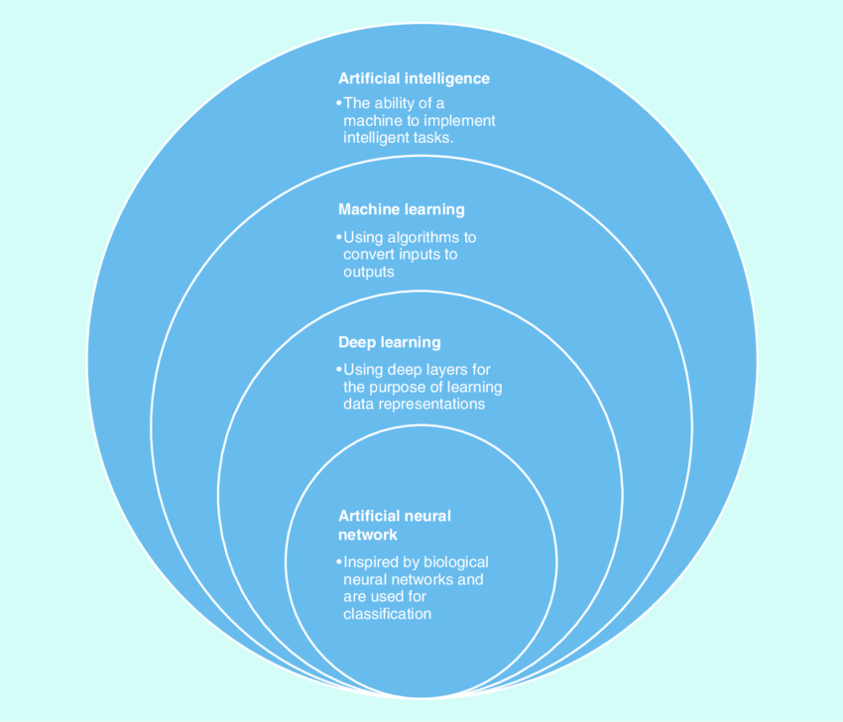

Fig 1.1:Subsets of AI

Neural Networks are modelled after the human brain to recognize patterns. They take data sets and recognize the pattern. They help to group unlabelled data on the basis of the similarities i.e. they help in classification and clustering. They can adapt to changes and generates the best possible result without the need to redesign the criteria of output.

The neural network is a set of algorithms patterned after the functioning of the human brain and the human nervous system. A neuron is a mathematical function that takes inputs and then classifies them according to the applied algorithm. It consists of an input layer, multiple hidden layers, and an output layer. It has layers of interconnected nodes. Each node is a perception that feeds the signal into an activation function.

## **1.4 NEURAL NETWORK LEARNING METHODS**

Neural networks are trained and taught just like a child’s developing brain is trained. They cannot be programmed directly for a particular task. They are trained in such a manner so that they can adapt according to the changing input. There are three methods or learning paradigms to teach a neural network.

**Supervised Learning :**

As the name suggests, supervised learning means in the presence of a supervisor or a teacher. It means a set of a labeled data set is already present with desired output i.e. the optimum action to be performed by the neural network which is already present for some data sets. The machine is then given new data sets to analyze the training data sets and to produce the correct output.

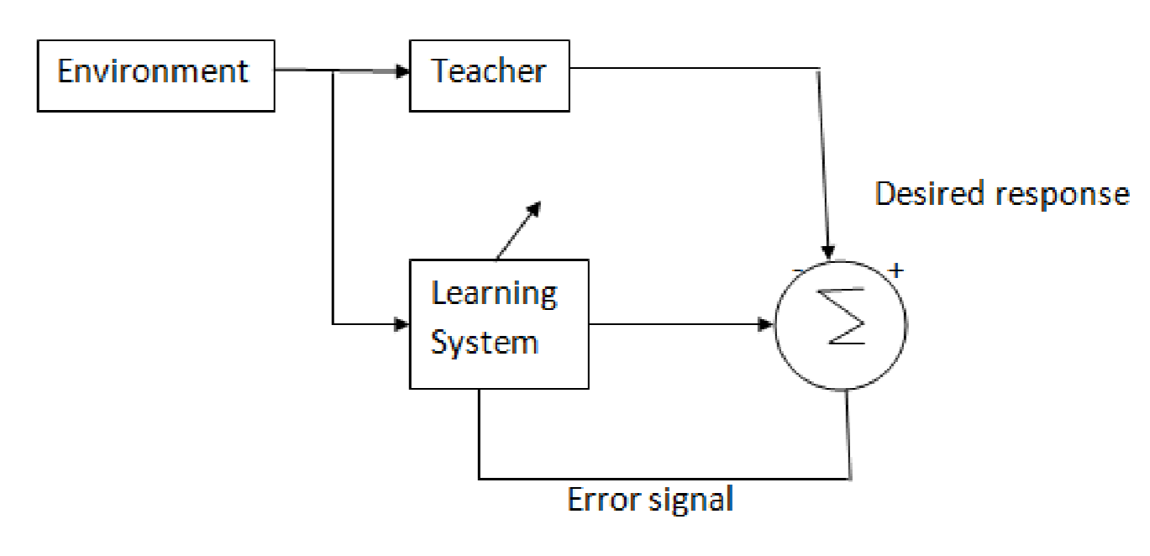

Fig.1.2 Supervised Learning

**Reinforcement Learning :**

In this, learning of input-output mapping is done by continuous interaction with the environment so that the scalar index of performance could be minimized. In this, instead of a teacher, there is a critic that converts the primary reinforcement signal i.e. the scalar input received from the environment into heuristic reinforcement signal (higher quality reinforcement signal) also a scalar input. The goal of this learning is to minimize the cost to go function i.e. the expected cumulative cost of actions taken over a sequence of steps.

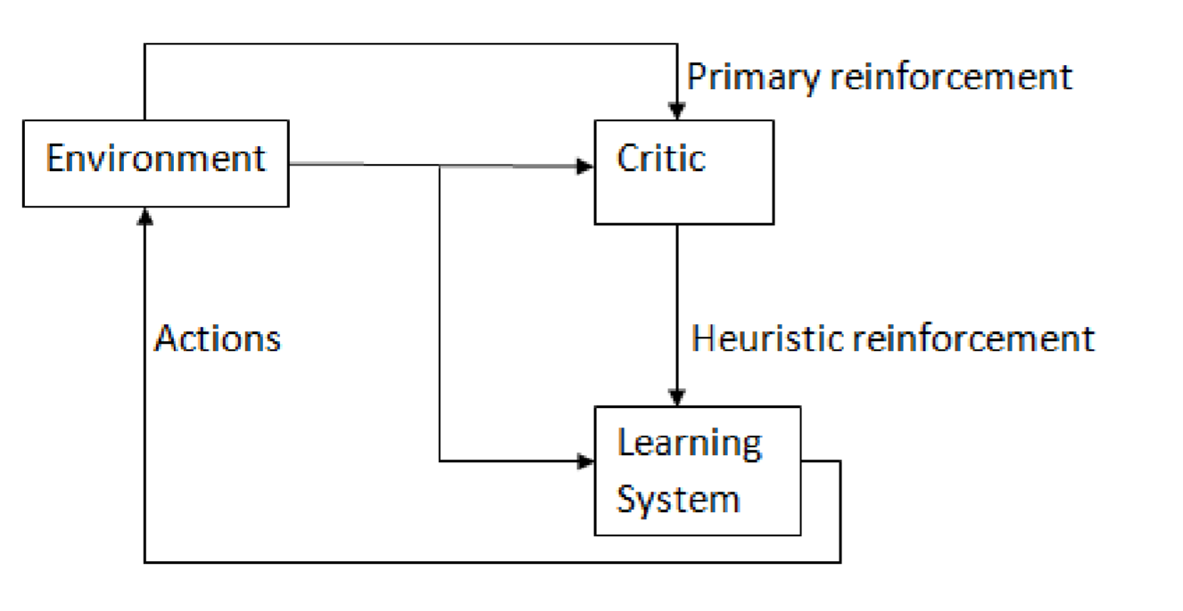

Fig 1.3. Reinforcement Learning

**Unsupervised Learning :**

As the name suggests, there is no teacher or supervisor available. In this, the data is neither labeled nor classified and no prior guidance is available to the neural network. In this, the machine has to group the provided data sets according to the similarities, differences, and patterns without any training provided beforehand.

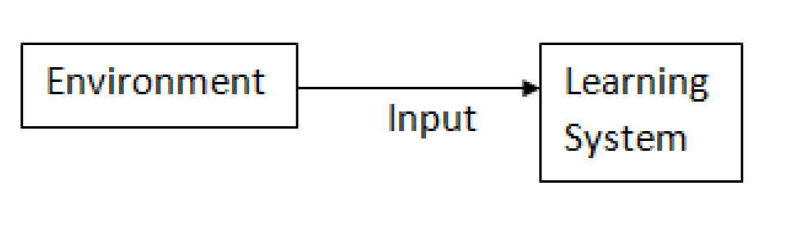

Fig 1.4. Unsupervised Learning

## **1.5 TYPES OF NEURAL NETWORKS**

1.Perceptron

2. Feedforward Neural Network

3.Radial Basis Function Neural Network

4.Multilayer Perceptron

5. Convolutional Neural Network

6.Recurrent Neural Network(RNN)

### ****1.5.1 PERCEPTRON****

The Perceptron is the most basic and oldest form of neural networks. It consists of just 1 neuron which takes the input and applies activation function on it to produce a binary output. It doesn’t contain any hidden layers and can only be used for binary classification tasks.

The neuron does the processing of addition of input values with their weights. The resulted sum is then passed to the activation function to produce a binary output.

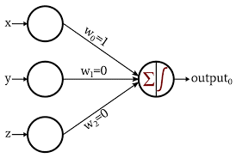

Fig 1.5.Perceptron

### ****1.5.2 FEED FORWARD NETWORK****

The Feed Forward (FF) networks consist of multiple neurons and hidden layers which are connected to each other. These are called “feed-forward” because the data flow in the forward direction only, and there is no backward propagation. Hidden layers might not be necessarily present in the network depending upon the application.

More the number of layers more can be the customization of the weights. And hence, more will be the ability of the network to learn. Weights are not updated as there is no backpropagation. The output of multiplication of weights with the inputs is fed to the activation function which acts as a threshold value.

FF networks are used in:

a)Classification

b)Speech recognition

c)Face recognition

d)Pattern recognition

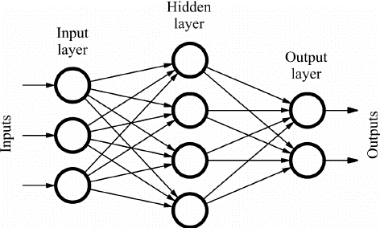

Fig 1.6.Feed Forward Network

### ****1.5.3 Multi-Layer Perceptron****

The main shortcoming of the Feed Forward networks was its inability to learn with backpropagation. Multi-layer Perceptrons are the neural networks which incorporate multiple hidden layers and activation functions. The learning takes place in a Supervised manner where the weights are updated by the means of Gradient Descent.

Multi-layer Perceptron is bi-directional, i.e., Forward propagation of the inputs, and the backward propagation of the weight updates. The activation functions can be changes with respect to the type of target. Softmax is usually used for multi-class classification, Sigmoid for binary classification and so on. These are also called dense networks because all the neurons in a layer are connected to all the neurons in the next layer.

They are used in Deep Learning based applications but are generally slow due to their complex structure.

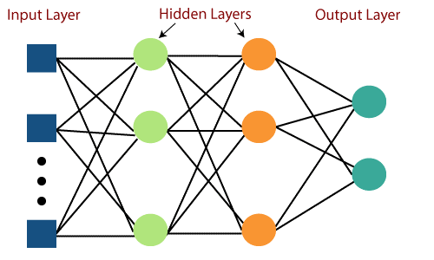

Fig 1.7.Multi-Layer Perceptron

### ****1.5.4 Radial Basis Networks****

Radial Basis Networks (RBN) use a completely different way to predict the targets. It consists of an input layer, a layer with RBF neurons and an output. The RBF neurons store the actual classes for each of the training data instances. The RBN are different from the usual Multilayer perceptron because of the Radial Function used as an activation function.

When the new data is fed into the neural network, the RBF neurons compare the Euclidian distance of the feature values with the actual classes stored in the neurons. This is similar to finding which cluster to does the particular instance belong. The class where the distance is minimum is assigned as the predicted class.

The RBNs are used mostly in function approximation applications like Power Restoration systems.

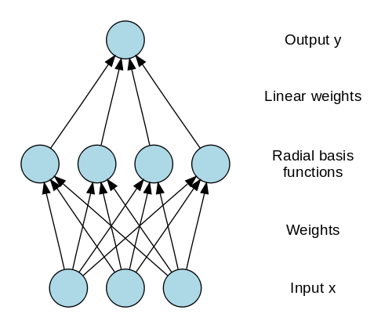

Fig 1.7.Radial Basis Network

### ****1.5.4 Convolutional Neural Networks****

When it comes to image classification, the most used neural networks are Convolution Neural Networks (CNN). CNN contain multiple convolution layers which are responsible for the extraction of important features from the image. The earlier layers are responsible for low-level details and the later layers are responsible for more high-level features.

The Convolution operation uses a custom matrix, also called as filters, to convolute over the input image and produce maps. These filters are initialized randomly and then are updated via backpropagation. One example of such a filter is the Canny Edge Detector, which is used to find the edges in any image.

After the convolution layer, there is a pooling layer which is responsible for the aggregation of the maps produced from the convolutional layer. It can be Max Pooling, Min Pooling, etc. For regularization, CNNs also include an option for adding dropout layers which drop or make certain neurons inactive to reduce overfitting and quicker convergence.

CNNs use ReLU (Rectified Linear Unit) as activation functions in the hidden layers. As the last layer, the CNNs have a fully connected dense layer and the activation function mostly as Softmax for classification, and mostly ReLU for regression.

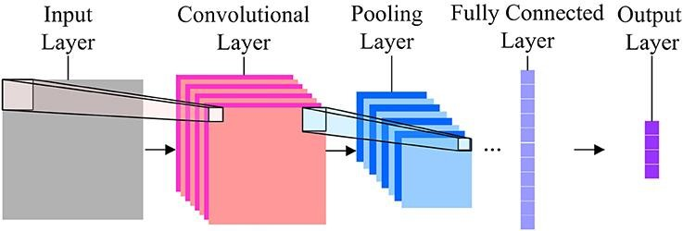

Fig 1.8 Convolutional Neural Network

### ****1.5.5 Recurrent Neural Networks****

Recurrent Neural Networks come into picture when there’s a need for predictions using sequential data. Sequential data can be a sequence of images, words, etc. The RNN have a similar structure to that of a Feed-Forward Network, except that the layers also receive a time-delayed input of the previous instance prediction. This instance prediction is stored in the RNN cell which is a second input for every prediction.

However, the main disadvantage of RNN is the Vanishing Gradient problem which makes it very difficult to remember earlier layers’ weights.

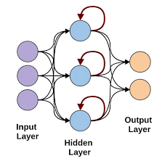

Fig 1.9 Recurrent Neural Network

## **1.6 DIGITAL IMAGE PROCESSING**

Image may be considered as a two-dimensional signal i.e., a function with two dimensions f(x,y) where x, y are spatial coordinates. From a geometry point of view, you can consider the image as a set of points on 2-d or 3-d space. Each point at every (x, y) is called amplitude or intensity of an image. When this amplitude and x, y points are discrete, then we call it a digital image. if the values are continuous values, then we call it an analog image. We can convert analog image to digital image using sampling and quantization. The process of manipulating digital images with a computer is called as digital image processing.

In a digital image, all the coordinates on 2-d function and the corresponding values are finite. Each value available in every location is considered as a pixel. In other words, a pixel is the smallest part of an image. So a digital image can be thought as 2-d array of pixels.

Each pixel has some intensity value which is called Gray level or Gray value. These values are usually represented in 8-bit int. So the range of values from 0 to 255. The values near to 0 indicates darker regions and the values near 255 represent brighter regions.

## **1.7 COLOR SPACE MODELS**

RGB COLOR SPACE:

RGB color space uses Red- Green-Blue component of the color and use those component to display the color. Using these three components, any color can be displayed

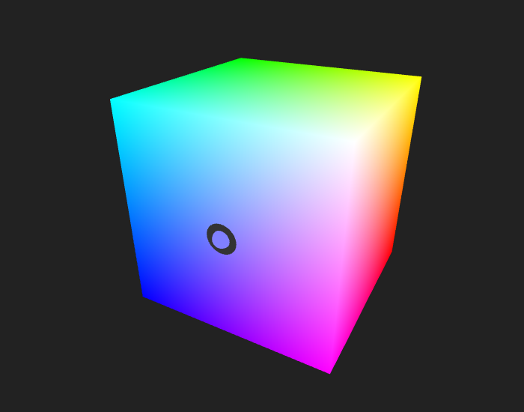

Fig 1.10 RGB COLOR SPACE

YCbCr COLOR SPACE:

YCbCr is also same like RGB. Another color space. But bit different spaces are taken. Here Y is the luma component of the color. Luma component is the brightness of the color. That means the light intensity of the color. The human eye is more sensitive to this component. Cb and Cr is the blue component and red component related to the chroma component. That means **“Cb is the blue component relative to the green component. Cr is the red component relative to the green component.”**These components are less sensitive to the human eyes. Since the Y component is more sensitive to the human eye, it needs to be more correct and Cb and Cr is less sensitive to the human eye. Therefore it needs not to be more accurate.

HSV COLOR SPACE:

HSV is a cylindrical color model that remaps the RGB primary colors into dimensions that are easier for humans to understand. Like the Munsell Color System, these dimensions are hue, saturation, and value.

Hue specifies the angle of the color on the RGB color circle. A 0° hue results in red, 120° results in green, and 240° results in blue.

Saturation controls the amount of color used. A color with 100% saturation will be the purest color possible, while 0% saturation yields grayscale.

Value controls the brightness of the color. A color with 0% brightness is pure black while a color with 100% brightness has no black mixed into the color

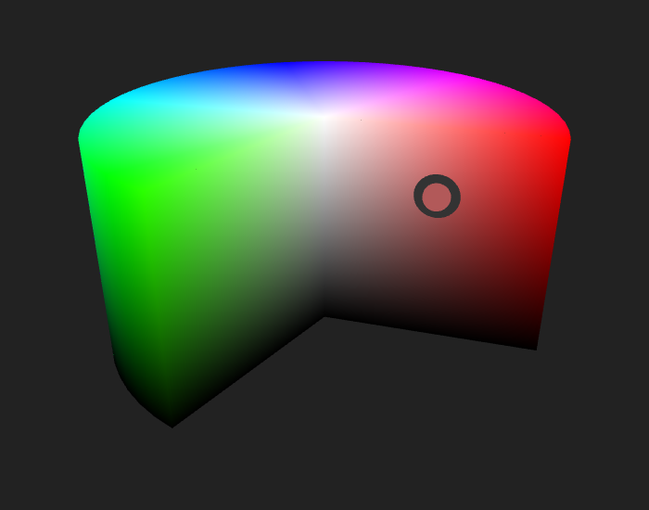

Fig 1.11 HSV COLOR SPACE

## **1.8 OBJECT RECOGNITION**

Object recognition is a general term to describe a collection of related computer vision tasks that involve identifying objects in digital photographs.

Image classification involves predicting the class of one object in an image. Object localization refers to identifying the location of one or more objects in an image and drawing a bounding box around their extent. Object detection combines these two tasks and localizes and classifies one or more objects in an image.

When a user or practitioner refers to “object recognition“, they often mean “object detection“.

As such, we can distinguish between these three computer vision tasks:

**Image Classification**: Predict the type or class of an object in an image.

Input: An image with a single object, such as a photograph.

Output: A class label (e.g. one or more integers that are mapped to class labels).

**Object Localization**: Locate the presence of objects in an image and indicate their location with a bounding box.

Input: An image with one or more objects, such as a photograph.

Output: One or more bounding boxes (e.g. defined by a point, width, and height).

**Object Detection**: Locate the presence of objects with a bounding box and types or classes of the located objects in an image.

Input: An image with one or more objects, such as a photograph.

Output: One or more bounding boxes (e.g. defined by a point, width, and height), and a class label for each bounding box.

One further extension to this breakdown of computer vision tasks is object segmentation, also called “object instance segmentation” or “semantic segmentation,” where instances of recognized objects are indicated by highlighting the specific pixels of the object instead of a coarse bounding box.

From this breakdown, we can see that object recognition refers to a suite of challenging computer vision tasks.

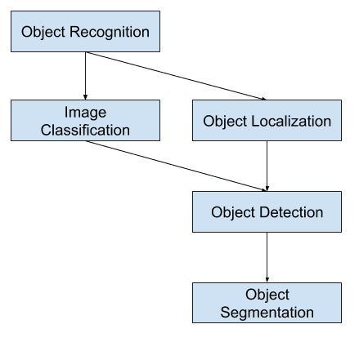

Fig 1.12 :Overview of Object Recognition Computer Vision Tasks

**Object Recognition**

Object recognition is the technique of identifying the object present in images and videos. It is one of the most important applications of machine learning and deep learning. The goal of this field is to teach machines to understand (recognize) the content of an image just like humans do.

**Image Classification**

In Image classification, it takes an image as an input and outputs the classification label of that image with some metric (probability, loss, accuracy, etc). For Example: An image of a cat can be classified as a class label “cat” or an image of Dog can be classified as a class label “dog” with some probability.

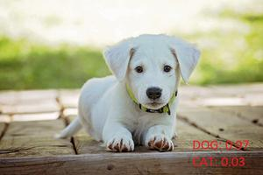

Fig 1.13 :Example of Image classification

**Object Localization**

Object Localization algorithm locates the presence of an object in the image and represents it with a bounding box. It takes an image as input and outputs the location of the bounding box in the form of (position, height, and width).

**Object Detection**

Object Detection algorithms act as a combination of image classification and object localization. It takes an image as input and produces one or more bounding boxes with the class label attached to each bounding box. These algorithms are capable enough to deal with multi-class classification and localization as well as to deal with the objects with multiple occurrences.

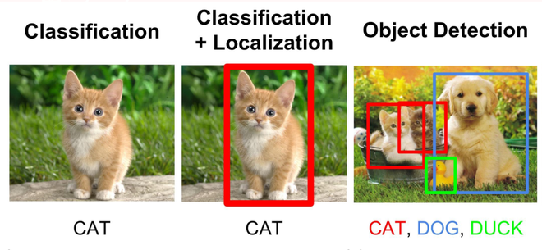

Fig 1.14 Example of Object recognition

**Challenges of Object Detection**

In object detection, the bounding boxes are always rectangular. So, it does not help with determining the shape of objects if the object contains the curvature part.

Object detection cannot accurately estimate some measurements such as the area of an object, perimeter of an object from image.

# Chapter-2

**SOFTWARE AND DATASETS**

# 2. SOFTWARE AND DATASETS

## **2.1 PYTHON**

**Python** is an [interpreted](https://en.wikipedia.org/wiki/Interpreted_language) [high-level](https://en.wikipedia.org/wiki/High-level_programming_language) [general-purpose programming language](https://en.wikipedia.org/wiki/General-purpose_programming_language). Python's design philosophy emphasizes [code readability](https://en.wikipedia.org/wiki/Code_readability) with its notable use of [significant indentation](https://en.wikipedia.org/wiki/Off-side_rule). Its [language constructs](https://en.wikipedia.org/wiki/Language_construct) as well as its [object-oriented](https://en.wikipedia.org/wiki/Object-oriented_programming) approach aim to help [programmers](https://en.wikipedia.org/wiki/Programmers) write clear, logical code for small and large-scale projects.

It is [dynamically-typed](https://en.wikipedia.org/wiki/Dynamic_programming_language) and [garbage-collected](https://en.wikipedia.org/wiki/Garbage_collection_(computer_science)). It supports multiple [programming paradigms](https://en.wikipedia.org/wiki/Programming_paradigms), including [structured](https://en.wikipedia.org/wiki/Structured_programming) , object-oriented and [functional programming](https://en.wikipedia.org/wiki/Functional_programming). Python is often described as a "batteries included" language due to its comprehensive [standard library](https://en.wikipedia.org/wiki/Standard_library).

### 2.1.1 FUNCTIONS IN PYTHON

A function in Python is an aggregation of related statements designed to perform a computational, logical, or evaluative task. The idea is to put some commonly or repeatedly done task together and make a function so that instead of writing the same code again and again for different inputs, we can call the function to reuse code contained in it over and over again.

Functions can be both built-in (or) user-defined. It helps the program to be concise, non-repetitive, and organized.

### 2.1.2 PYTHON FEATURES

Easy to code:Python is a high-level programming language. Python is very easy to learn the language as compared to other languages like C, C#, Java script, Java, etc. It is very easy to code in python language and anybody can learn python basics in a few hours or days. It is also a developer-friendly language.

1)Free and Open Source  
2)Object-Oriented Language

3)Large Standard Library

4)High-Level Language.

**Characteristics of Python:**

It supports functional and structured programming methods as well as OOP.

It can be used as a scripting language or can be complied to byte-code for building large applications.

### 2.1.3 CV2 PACKAGE IN PYTHON:

Open CV-Python is a Python wrapper for the original Open CV C++ implementation.

Open CV-Python makes use of Numpy, which is a highly optimized library for numerical operations with a MATLAB-style syntax. All the Open CV array structures are converted to and from Numpy arrays. This also makes it easier to integrate with other libraries that use Numpy such as SciPy and Matplot lib. Open CV introduces a new set of tutorials which will guide you through various functions available in Open CV-Python.

**Functions in Opencv:**

**1)Imread function in OpenCV:** We use the imread function to read images

**2)Imwrite function in OpenCV:** We can use OpenCV’s imwrite() function to save an image in a storage device.

**3)Resize function in OpenCV:** We use an inbuilt resize() method to resize an image.

**4)Drawing Rectangle**: We can draw a rectangle in a image using cv2.rectangle() method

5)We have Canny() method to implement this algorithm.Here is the syntax:

**edges = cv2.Canny(img, minVal, maxVal, apertureSize, L2gradient)**

Parameters-

Img: input image whose edges we want to detect

minVal: Minimum intensity gradient(required)

maxVal:Maximum intensity gradient(required)

L2gradient: is a flag with default value =False, indicating the default L1 norm is enough to calculate the image gradient magnitude ,If its is a True a more accurate L2 norm is used to calculate the image gradient magnitude but it is computationally more expensive.

apertureSize:aperture size for Sobel Operator

6) In OpenCV,we use two functions,one to find contours and other to draw contours.We use findContours() function to find contours and drawCounter() to draw one.

Here is the syntax of these functions.

**image, contours, hierarchy=cv.findContours(img, mode, method,contours, hierarchy,offset)**

This function returns three objects:

**Img**:The input image in which we have to find contours

**Contours:** It containsdetected contours and  contour is stored as a vector of points.

**Hierarchy:**Optional output vector, containing information about the image topology. It has as many elements as the number of contours. For each i-th contour contours[i], the elements hierarchy[i][0] , hierarchy[i][1] , hierarchy[i][2] , and hierarchy[i][3] are set to 0-based indices in contours of the next and previous contours at the same hierarchical level, the first child contour and the parent contour, respectively. If for the contour i there are no next, previous, parent, or nested contours, the corresponding elements of hierarchy[i] will be negative.

**Parameters of this function:**

**mode:** Contour retrieval mode

**method**:Contour approximation method

**offset :** Optional offset by which every contour point is shifted. This is useful if the contours are extracted from the image ROI and then they should be analyzed in the whole image context.

**Here is the syntax of drawCounter():**

**cv.drawContours(image, contours, contourIdx, color, thickness, lineType, hierarchy, maxLevel, offset)**

Parameters

**Image**: Input image

**contours**:All the input contours. Each contour is stored as a point vector.

**contourIdx**:Parameter indicating a contour to draw. If it is negative, all the contours are drawn.

**color**:Color of the contours.

**thickness**:Thickness of lines the contours are drawn with. If it is negative (for example, thickness=FILLED ), the contour interiors are drawn.

**lineType**:Line connectivity

**hierarchy**:Optional information about hierarchy. It is only needed if you want to draw only some of the contours (see maxLevel ).

**maxLevel**:Maximal level for drawn contours. If it is 0, only the specified contour is drawn. If it is 1, the function draws the contour(s) and all the nested contours. If it is 2, the function draws the contours, all the nested contours, all the nested-to-nested contours, and so on. This parameter is only taken into account when there is hierarchy available.

**offset**:Optional contour shift parameter. Shift all the drawn contours by the specified offset=(dx,dy).

**Popular Packages in Python**

**Os:** The OS module in Python provides functions for interacting with the operating system. OS comes under Python's standard utility modules. This module provides a portable way of using operating system dependent functionality. The *os* and *os.path* modules include many functions to interact with the file system.

**Numpy:** NumPy is the fundamental package for scientific computing in Python. It is a Python library that provides a multidimensional array object, various derived objects (such as masked arrays and matrices), and an assortment of routines for fast operations on arrays, including mathematical, logical, shape manipulation, sorting, selecting, I/O, discrete Fourier transforms, basic linear algebra, basic statistical operations, random simulation and much more.

**Sklearn:**

Scikit-learn (Sklearn) is the most useful and robust library for machine learning in Python. It provides a selection of efficient tools for machine learning and statistical modeling including classification, regression, clustering and dimensionality reduction via a consistence interface in Python. This library, which is largely written in Python, is built upon NumPy, SciPy and Matplotlib.

**Skimage:** scikit-image (a.k.a. skimage) is a collection of algorithms for image processing and computer vision.

**Subpackages in Skimage**:

**exposure:**Image intensity adjustment, e.g., histogram equalization, etc.

**io:**Reading, saving, and displaying images and video.

**transform:**Geometric and other transforms, e.g., rotation or the Radon transform.

**Matplotlib:** Matplotlib is a comprehensive library for creating static, animated, and interactive visualizations in Python.

**Seaborn :**It is a Python data visualization library based on [matplotlib](https://matplotlib.org/). It provides a high-level interface for drawing attractive and informative statistical graphics.

**Pandas:**It is a [software library](https://en.wikipedia.org/wiki/Software_library) written for the [Python programming language](https://en.wikipedia.org/wiki/Python_(programming_language)) for data manipulation and [analysis](https://en.wikipedia.org/wiki/Data_analysis). In particular, it offers [data structures](https://en.wikipedia.org/wiki/Data_structure) and operations for manipulating numerical tables and [time series](https://en.wikipedia.org/wiki/Time_series)

**h5py:**The h5py package provides both a high- and low-level interface to the HDF5 library from Python. The low-level interface is intended to be a complete wrapping of the HDF5 API, while the high-level component supports access to HDF5 files, datasets and groups using established Python and NumPy concepts.

## **2.2 TENSORFLOW**

Tensor Flow is a Python library for fast numerical computing created and released by Google.

It is a foundation library that can be used to create Deep Learning models directly or by using wrapper libraries that simplify the process built on top of [Tensor Flow](https://machinelearningmastery.com/tensorflow-tutorial-deep-learning-with-tf-keras/).

It was created and is maintained by Google and released under the Apache 2.0 open source license. The API is nominally for the Python programming language, although there is access to the underlying C++ API.

Unlike other numerical libraries intended for use in Deep Learning like Theano , Tensor Flow was designed for use both in research and development and in production systems, not least [RankBrain in Google search](https://en.wikipedia.org/wiki/RankBrain) and the fun [DeepDream project](https://en.wikipedia.org/wiki/DeepDream).

It can run on single CPU systems, GPUs as well as mobile devices and large scale distributed systems of hundreds of machines.

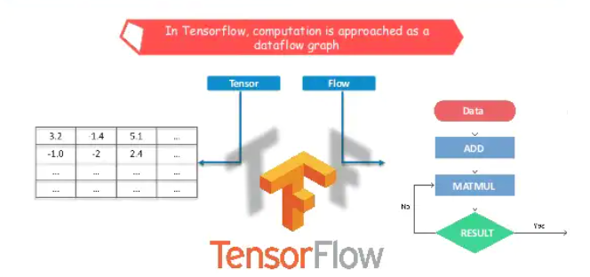

Fig 2.1 Tensorflow Logo

**2.2.1 FEATURES OF TENSOR FLOW:**

In the emerging era of advancement, data plays an important role; where it collects the data, analyses it and makes predictions providing a more user-friendly environment. With such technology, it trains the systems using machine-learning to provide rules using given data and output. Implementing machine learning is a complex stream concerning the creation of real-time models. Hence the framework- TensorFlow is used for collecting datasets, training systems through models and providing the results based on it.

Tensor Flow is an open-source framework created by Google. It executes machine learning and neural networks with the help of python. It builds an environment of networks to experiment with the algorithms of machine learning and visualizes it using flow graphs. The graphs represent the progression of all nodes where nodes are the operations in the model.

Once the model is created, you can config the model with losses and metrics with model.compile(), train the model with model.fit(), or use the model to do prediction with model.predict().

Model.fit_generator():Fits the model on data yielded batch-by-batch by a Python generator.

fit_generator(  
    generator, steps_per_epoch=None, epochs=1, verbose=1, callbacks=None,  
    validation_data=None, validation_steps=None, validation_freq=1,  
    class_weight=None, max_queue_size=10, workers=1, use_multiprocessing=False,  
    shuffle=True, initial_epoch=0  
)

Tensor Flow features are as follows:

1. Open-source Library

It is an open-source library that allows rapid and easier calculations in machine learning. It eases the switching of algorithms from one tool to another Tensor Flow tool. With the help of python, it provides the front-end API for the development of various machines and deep learning algorithms.

2. Easy to run

We can execute Tensor Flow applications on various platforms such as [Android](https://data-flair.training/blogs/android-tutorial/), Cloud, IOS and various architectures such as CPUs and GPUs. This allows it to be executed on various embedded platforms. Tensor Flow has its own designed hardware to train the neural models known as [Cloud TPUs](https://cloud.google.com/tpu) (Tensor Flow Processing unit).

3. Fast Debugging

It allows you to reflect each node, i.e., operation individually concerning its evaluation. Tensor Board works with the graph to visualize its working using its dashboard. It provides computational graphing methods that support an easy to execute paradigm.

4. Effective

It works with multi-dimensional arrays with the help of data structure tensor which represents the edges in the flow graph. Tensor identifies each structure using three criteria: rank, type, shape.

5. Scalable

It provides room for prediction of stocks, products, etc with the help of training using the same models and different data sets. It also allows for synchronous and asynchronous learning techniques and data ingestion. The graphical approach secures the distributed execution parallelism.

6. Easy Experimentation

Tensor Flow transforms the raw data to the estimators-a form of data neural networks understand. Tensor Flow feature columns allow the bridge between raw data and estimators to train the model. This adds the agility to the model for fast developmental insights.

7. Abstraction

Tensor Flow provides a defined level of abstraction by reducing the code length and cutting the development time. The user needs to focus on logic disregarding the proper way of providing input to functions. A user can choose the model apt according to the system’s requirement.

8. Flexibility

Tensor Flow provides the process of resolving complex topologies with the support of Keras API and data input pipelines. Keras provides easy prototyping and suits best for object-oriented neural networks.

Tensor Flow eases the mechanism of machine learning with the assistance of such characteristics. It allows the user to create and manipulate the system to create different types of real-time models.

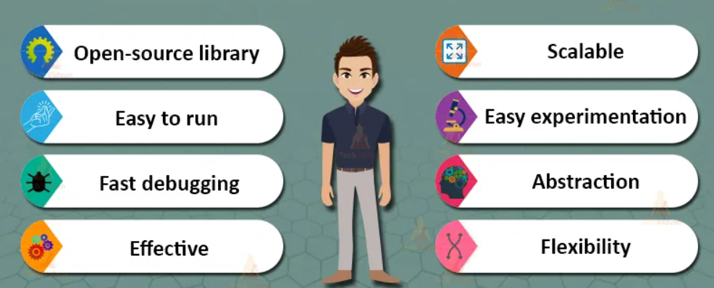

Fig 2.2 Features of Tensorflow

### 2.2.2 APPLICATIONS OF TENSOR FLOW:

Tensor Flow is a great tool, which, if used properly, has innumerable benefits. The major uses of the library include classification, perception, understanding, discovering, prediction, and creation. Some of the current uses of the Tensor Flow system, Tensor Flow application, and some other awesome projects done by the open-source community are listed below:

* Speech Recognition Systems
* Image/Video Recognitionand tagging
* Self Driving Cars
* Text Summarization
* Sentiment Analysis

## **2.3 GOOGLE COLAB**

Colaboratory, or “Colab” for short, is a product from Google Research. Colab allows anybody to write and execute arbitrary python code through the browser, and is especially well suited to machine learning, data analysis and education. More technically, Colab is a hosted Jupyter notebook service that requires no setup to use, while providing free access to computing resources including GPUs.



Fig 2.3 . google colab logo

### 2.3.1 INTRODUCTION TO COLAB

**How to use Google Colab :**

If you want to create a machine learning model but say you don’t have a computer that can take the workload, Google Colab is the platform for you. Even if you have a GPU or a good computer creating a local environment with anaconda and installing packages and resolving installation issues are a hassle. Colaboratory is a free Jupyter notebook environment provided by Google where you can use free GPUs and TPUs which can solve all these issues.

Colaboratory is a hosted Jupyter notebook environment that is free to use and requires no setup.

It’s important features are :

1. Tensor Flow is already pre-installed : When you create a new notebook on colab.research.google.com, Tensor Flow is already preinstalled and optimized for the hardware being used. Just import tensor flow as tf, and start coding.

2. Setup your libraries and data dependencies in code cells : Creating a cell with !pip install or !apt-get works as you’d expect. It also makes it easy for others to reproduce your setup.

3. Use it with Github : You can also easily save a copy of your Colab notebook to Github by using File > Save a copy to Github.

4. Share and edit collaboratively : Colab notebooks are just like Google Docs and Sheets. They are stored in Google Drive and can be shared, edited, and commented on collaboratively. Just click the Share button in the top right of any notebook that you’ve created.

5. Hardware acceleration : By default, Colab notebooks run on CPU. You can switch your notebook to run with GPU by going to Runtime > Change runtime type, and then selecting GPU.

from “Runtime type” dropdown menu.

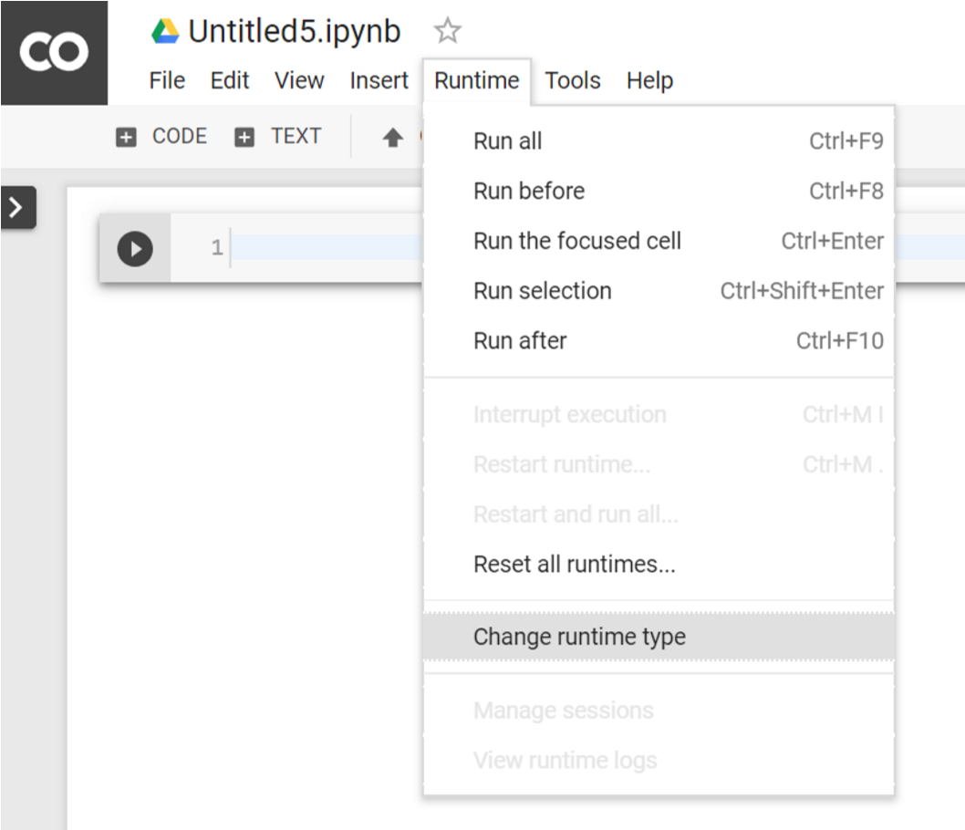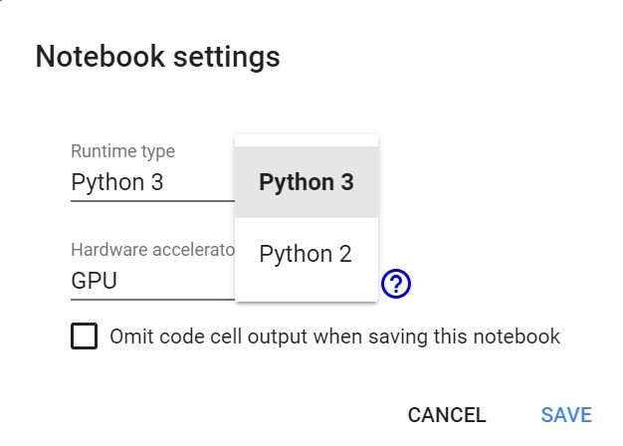

Fig 2.4 Changing Runtype to GPU

2.

To mount Google Drive with Colab, execute the following code in Code cell

Fig

2.5

Mounting Drive to Colab

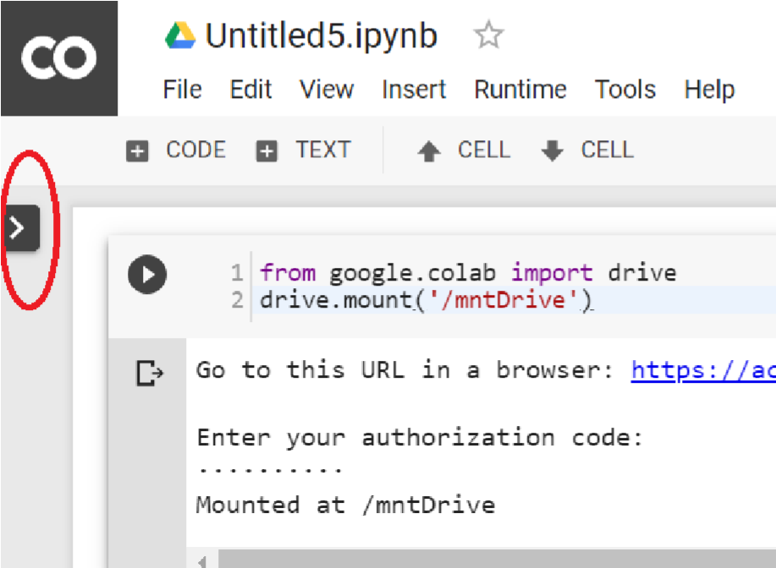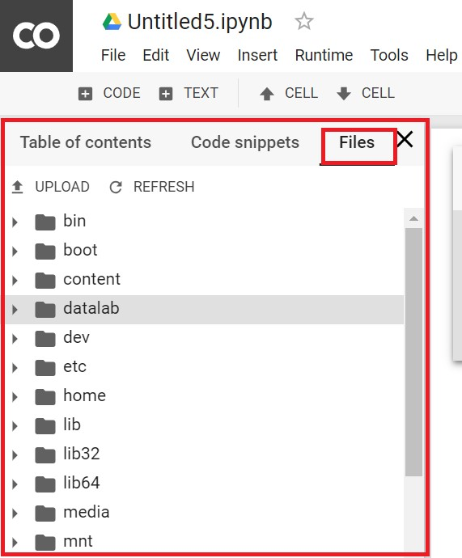

**2.4 GERMEN SIGN DATASETS:**

**2.4.1 INTRODUCTION TO DATASET**

The German Traffic Sign Benchmark is a multi-class, single-image classification challenge held at the [International Joint Conference on Neural Networks (IJCNN) 2011](http://www.ijcnn2011.org/).

Traffic sign detection is a high relevance computer vision problem and is the basis for a lot of applications in industry such as Automotive etc. Traffic signs can provide a wide range of variations between classes in terms of colour, shape, and the presence of pictograms or text.

In this challenge, we will develop a deep learning algorithm that will train on German traffic sign images and then classify the unlabeled traffic signs. The deep learning model will be built using Keras (high level API for tensor flow) and we will also understand various ways to pre process images using openCV and also use a cloud GPU service provider.

We will be working with Keras for our algorithm building. Keras was chosen as it is easy to learn and use. Keras also seamlessly integrates well with Tensor Flow. After Tensor flow, Keras seems to be the framework that is widely used by the deep learning community.

### 2.4.2 DATA UNDERSTANDING

The Image dataset consists of 43 classes (Unique traffic sign images).Training Set has 34799 Images , Test set has 12630 images and the validation set has 4410 images.

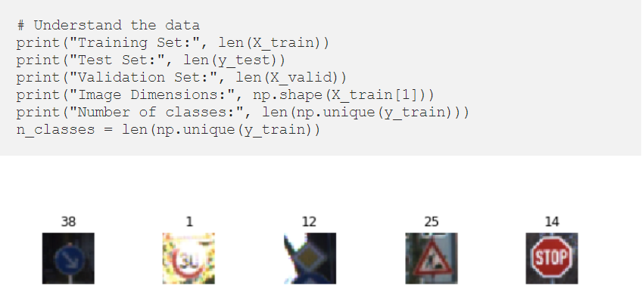

Fig 2.6. sample image of dataset

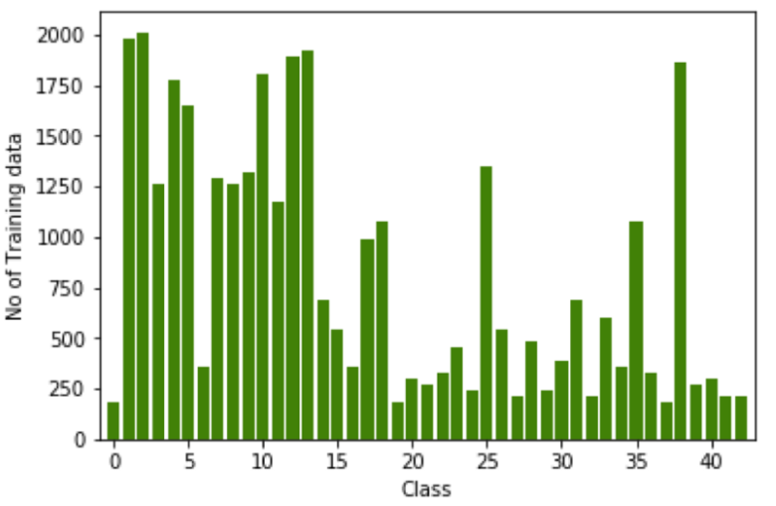

Fig.2.7 class distribution

### 2.4.3 DATA AUGMENTATION

Now that we have a score at hand, lets understand if pre-processing the images would lead to a better accuracy score and help our model.

Data Augmentation is used to increase the training set data. Augmenting the data is basically creating more images from the available images but with slight alteration of the images. We generally need data proportional to the parameters we feed the neural networks .Found Open CV to be excellent for image pre processing. Here’s the link to the general tutorials to use Open CV with Python implementation. Some of the techniques used in the process are Rotation, Translation, Bi lateral filtering, Gray scaling and Local Histogram Equilization.

**Slight Rotation of Images:**Used 10 degrees rotation of images. It would not make much sense to rotate images more than that as that might lead to wrong representations of the traffic signs. Let’s view few images after slight rotation(not that noticeable in few images also)

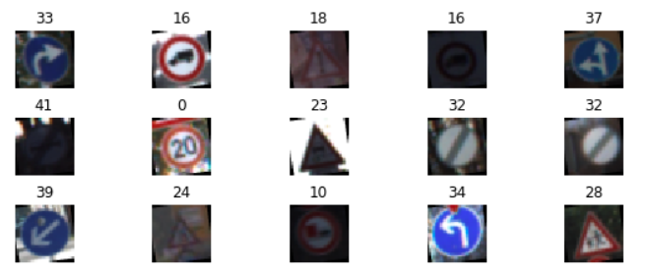

Fig 2.8. image after 10 degree rotation

**Image Translation:**This is a technique by which you shift the location of the image. In layman terms, if the image’s location is (x1,y1) position, after translation it is moved to (x2,y2) position. As you can see from the below images, the location is slightly moved downwards.

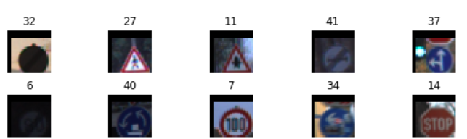

Fig 2.9. image after translation

**Local Histogram Equalization:**This is done to increase the contrast of the images as we had identified during “Data Understanding” that the images might need an increase in contrast.

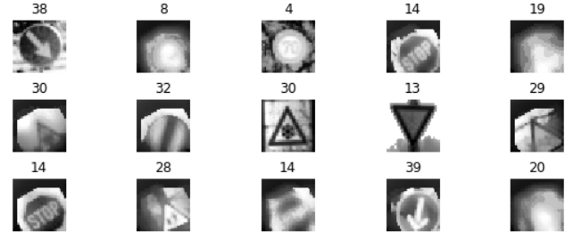

Fig. 2.10 image after pre-processing

**Fixing Class Bias with Data augmentation:** We are set to increase to the training set images with data augmentation, it would also make sense to address the class bias issue. Hence during augmentation, all the classes were fed with 4000 images. In the original dataset Class 2 had the maximum number of training images with 2010 records. The number 4000 (Max class records * ~2)is an arbitrary number I took to make all classes have same number of records. We can definitely play around this distribution further.

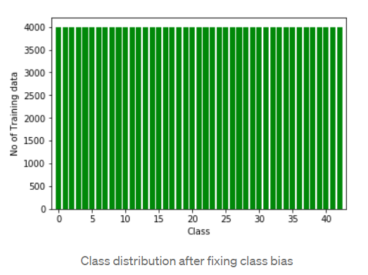

Fig 2.11 Class distribution after fixing class bias

# Chapter-3

**CLASSIFICATION METHODOLOGY**

# CLASSIFICATION METHODOLOGY:

Most classification methods perform model construction based on feature vectors. However, sequences do not have explicit features. Even with sophisticated feature selection techniques, the [dimensionality](https://www.sciencedirect.com/topics/computer-science/dimensionality) of potential features can still be very high and the sequential nature of features is difficult to capture. This makes sequence classification a challenging task.

**3.1 FORWARD PROPAGATION:**

* 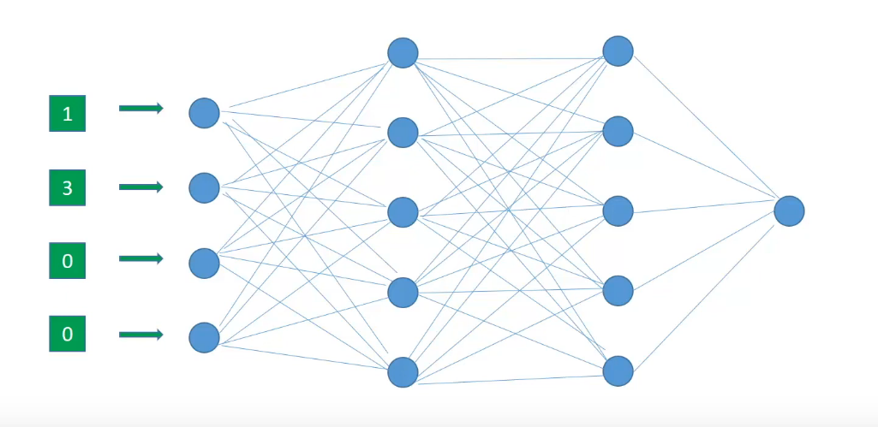

Fig 3.1 Neuaral Network

Now we start off the forward propagation by randomly initializing the weights of all neurons. These weights are depicted by the edges connecting two neurons. Hence the weights of a neuron can be more appropriately thought of as weights between two layers since edges connect two layers.

Now let’s talk about this first neuron in the first hidden layer.

.

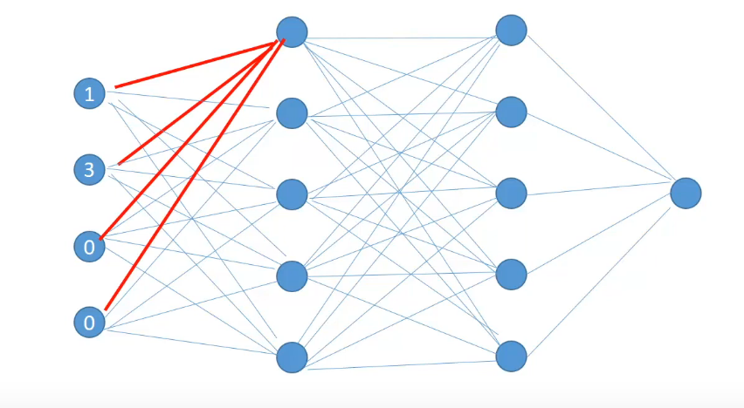

Fig 3.2 First Neuron in Hidden Layer

This neuron receives input from all the neurons in the previous layer and combines it with its own set of weights represented by the red edges. And after applying some activation function, calculates the output known as Hidden Activation for this neuron. The output of the hidden activation will serve as input for the next layer neurons. Similarly, the hidden activations for all of the neurons in the layer are calculated.

So all the activations for the first hidden layer have been calculated. These activations will serve as inputs to the layer after them. Once the hidden activations for the last hidden layer are calculated, they are combined by a final set of weights between the last hidden layer and the output layer to produce an output for a single row observation.

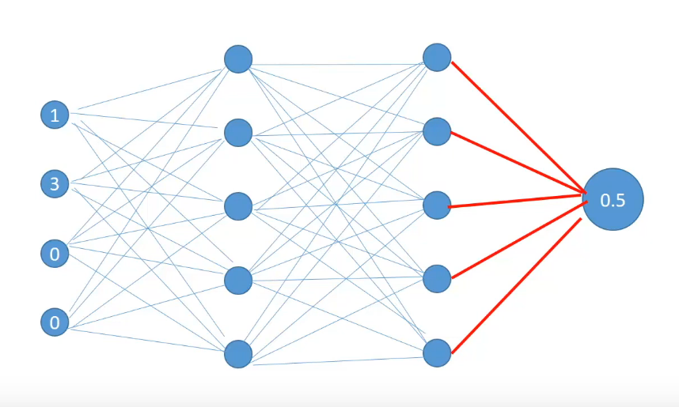

Fig 3.3 Output of Neural network

These calculations of the first row features are 0.5 and the predicted value becomes 0.5 against the actual value of 0.

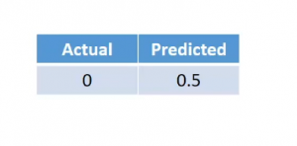

Fig 3.4 actual and predicted output

Now if you notice that carefully we calculated the hidden activations for each of the neurons sequentially, that is one after the other. In fact, one optimization that we can make to the calculation is to calculate them in parallel. Since the calculation of neurons is independent of each other they can be computed in parallel easily. We can calculate the first hidden activation simultaneously-

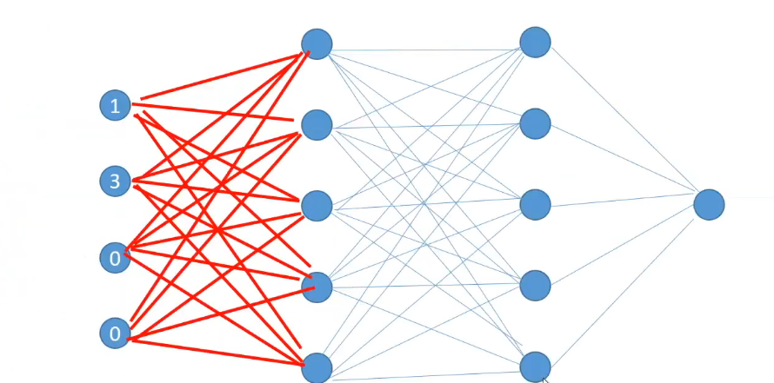

Fig 3.5 calculation of hidden activations

then calculate the activation of the second layer simultaneously,

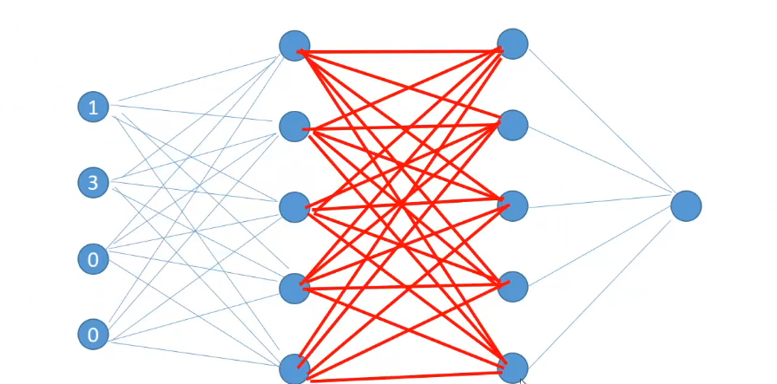

Fig 3.6 calculation of second hidden activations

and then finally calculate the output.

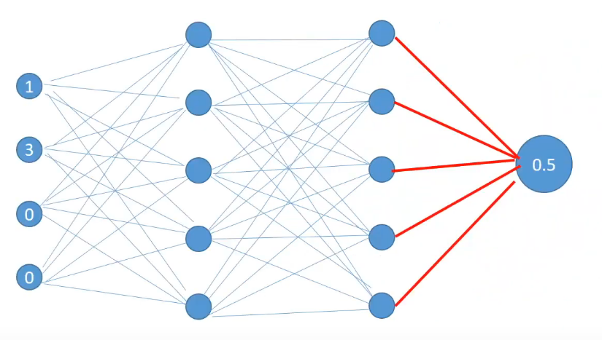

Fig 3.7 calculation of output

**This series of calculations which takes us from the input to output is called Forward Propagation.**

We will now understand the error generated during the predictions and what can be the possible reasons behind those errors.

## **3.2 ERRORS IN NEURAL NETWORKS**

So far we have seen how forward propagation helps us in calculating outputs. Let’s say for a particular row the actual target is 0 and the predicted target is 0.5. We can use this predicted value to calculate the error for a particular row. The kind of error that we have chosen here is Squared Error.

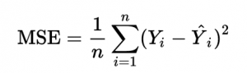

There can be other error calculation formulas but for the sake of simplicity, we have chosen this one.

**What can be changed to reduce error:**

Now that we have an error what can be possible reasons for this and what can be changed to reduce errors? We know that the error is directly dependent upon two quantities- the actual values and the predicted values.

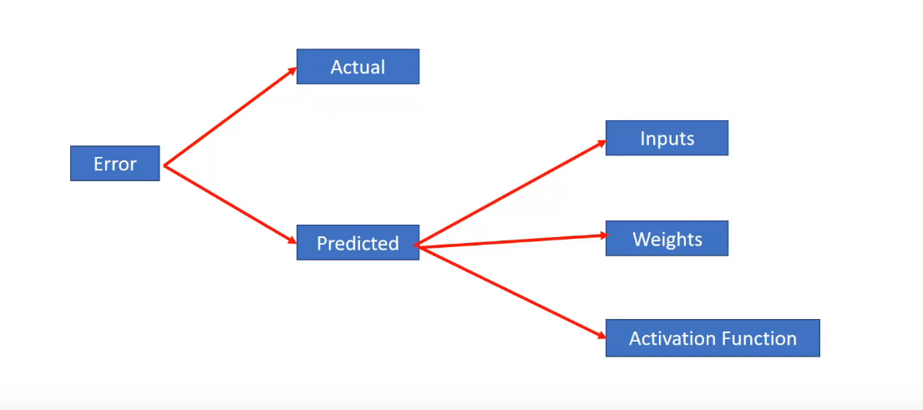

Fig 3.8 what can be changed to reduce error

We cannot change the actual values so this is out of the possible suspects. Next, we know that the predicted values which are also the hidden activations are dependent upon 3 things-

a)Inputs to the output layer i.e the hidden activation of the second layer

b)Weights between the second hidden layer and the output

c)And the activation function present at the output layer

We cannot directly modify the second hidden layer activations since they’re calculated at each step. So inputs are also out. We can change both the activation functions and weights but we cannot iteratively change activation functions as it would change distributions during the training time. So activation function is also out of the question.

Now, what remains are the weights between the second hidden layer and output. In fact not only can we change the weights between the second hidden layer and the output but also between the first and the second hidden layer and between the input layer and the first hidden layer. But we cannot change the weights in arbitrary amounts to check out what weights produce the lowest error as this would amount to an infinite amount of time to check what sort of weights produce the lowest error.

**How to reduce Errors:**

Interestingly what we can do is we can use a smart strategy to adjust the weights and reduce the errors. Specifically what we are interested is in two things-

First is the amount of change in error on changing the weight by a small amount And second is the direction of that change.

## **3.3 TASKS**

### 3.3.1 MULTI-CLASS CLASSIFICATION

One-of-many classification. Each sample can belong to one of C classes. The CNN will have C output neurons that can be gathered in a vector s (Scores). The target (ground truth) vector t will be a one-hot vector with a positive class and C−1 negative classes. This task is treated as a single classification problem of samples in one of C classes.

### 3.3.2 MULTI-LABEL CLASSIFICATION

#### Each sample can belong to more than one class. The CNN will have as well C output neurons.The target vector t can have more than a positive class, so it will be a vector of 0s and 1s with dimensionality. This task is treated as C different binary (C′=2,t′=0 or t′=1)(C′=2,t′=0 or t′=1) and independent classification problems, where each output neuron decides if a sample belongs to a class or not.

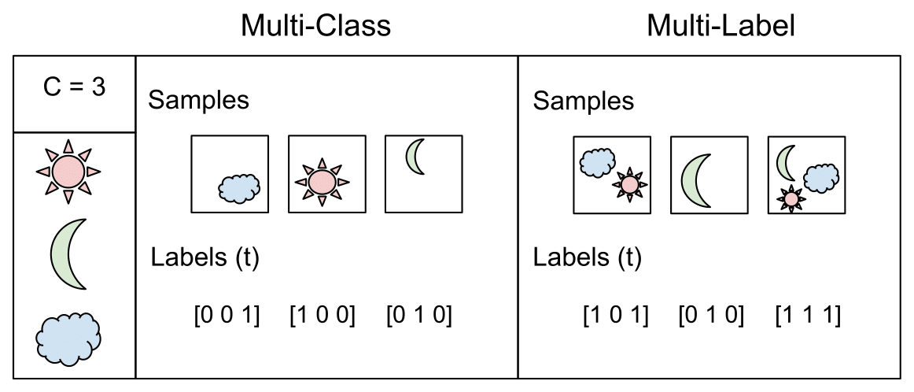

Fig 3.9 Examples for Multi-class and Multi-Label

## **3.4 LOSSES**

### 3.4.1 CROSS-ENTROPY LOSS

The **Cross-Entropy Loss**  is defined as:

[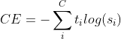](https://www.codecogs.com/eqnedit.php?latex=CE&space;=&space;-\sum_%7bi%7d%5e%7bC%7dt_%7bi%7d&space;log&space;(s_%7bi%7d))

Where ti and si are the groundtruth and the CNN score for each class i in C

In a binary classification problem, where C′=2, the Cross Entropy Loss can be defined also as:

[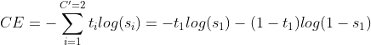](https://www.codecogs.com/eqnedit.php?latex=CE&space;=&space;-\sum_%7bi=1%7d%5e%7bC'=2%7dt_%7bi%7d&space;log&space;(s_%7bi%7d)&space;=&space;-t_%7b1%7d&space;log(s_%7b1%7d)&space;-&space;(1&space;-&space;t_%7b1%7d)&space;log(1&space;-&space;s_%7b1%7d))

Where it’s assumed that there are two classes: C1 and C2. t1 [0,1] and s1 are the groundtruth and the score for C1, and t2=1−t1 and s2=1−s1 are the groundtruth and the score for C2. That is the case when we split a Multi-Label classification problem in C binary classification problem

### 3.4.2 CATEGORICAL CROSS-ENTROPY LOSS

If we use this loss, we will train a CNN to output a probability over the C classes for each image. It is used for multi-class classification.

### 3.4.3 BINARY CROSS-ENTROPY LOSS

it is independent for each vector component (class), meaning that the loss computed for every CNN output vector component is not affected by other component values. That’s why it is used for **multi-label classification**, were the insight of an element belonging to a certain class should not influence the decision for another class. It’s called **Binary Cross-Entropy Loss** because it sets up a binary classification problem between C′=2 classes for every class.

## **3.5 BACKPROPAGATION**

**Backpropagation** is the essence of neural network training. It is the method of fine-tuning the weights of a neural network based on the error rate obtained in the previous epoch (i.e., iteration). Proper tuning of the weights allows you to reduce error rates and make the model reliable by increasing its generalization.

**Backpropagation Algorithm Workflow**

The Back propagation algorithm in neural network computes the gradient of the loss function for a single weight by the chain rule. It efficiently computes one layer at a time, unlike a native direct computation. It computes the gradient, but it does not define how the gradient is used. It generalizes the computation in the delta rule.

Consider the following Back propagation neural network example diagram to understand:

[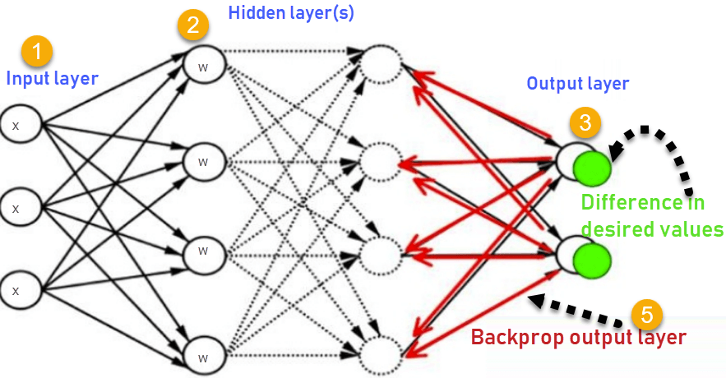](https://www.guru99.com/images/1/030819_0937_BackPropaga1.png)How

Fig 3.10 Back propagation

Back propagation Algorithm Works

1. Inputs X, arrive through the preconnected path.
2. Input is modeled using real weights W. The weights are usually randomly selected.
3. Calculate the output for every neuron from the input layer, to the hidden layers, to the output layer.
4. Calculate the error in the outputs

Error= Actual Output – Desired Output

1. Travel back from the output layer to the hidden layer to adjust the weights such that the error is decreased.

Keep repeating the process until the desired output is achieved

Most prominent advantages of Back propagation are:

* Back propagation is fast, simple and easy to program
* It has no parameters to tune apart from the numbers of input
* It is a flexible method as it does not require prior knowledge about the network
* It is a standard method that generally works well
* It does not need any special mention of the features of the function to be learned.

## **3.6 ADAM OPTIMIZER:**

Adaptive Moment Estimation is an algorithm for optimization for optimization technique for gradient descent. The method is really efficient when working with large problem involving a lot of data or parameters. It requires less memory and is efficient. Intuitively , it is a combination of the ‘gradient descent with momentum ‘ algorithm and the ‘RMSP’ algorithm.

**Adam workflow:**

Adam optimizer involves a combination of two gradient descent methodologies:

**3.6.1 MOMENTUM**

This algorithm is used to accelerate the gradient descent algorithm by taking into consideration the 'exponentially weighted average' of the gradients. Using averages makes the algorithm converge towards the minima in a faster pace.

where,

$$w_{\left\{t+1\right\}}=w_{\left\{t\right\}}-αm_{\left\{t\right\}}$$

$$m_{\left\{t\right\}}=βm_{\left\{t-1\right\}}+\left(1-β\right)\left.\left[\frac{δL}{δw_{\left\{t\right\}}}\right.\right]$$

mt = aggregate of gradients at time t [current] (initially, mt = 0)

mt-1 = aggregate of gradients at time t-1 [previous]

Wt = weights at time t

Wt+1 = weights at time t+1

αt = learning rate at time t

∂L = derivative of Loss Function

∂Wt = derivative of weights at time t

β = Moving average parameter (const, 0.9)

### ****3.6.2 ROOT MEAN SQUARE PROPAGATION (RMSP):****

Root mean square prop or RMSprop is an adaptive learning algorithm that tries to improve AdaGrad. Instead of taking the cumulative sum of squared gradients like in AdaGrad, it takes the 'exponential moving average'.

$$w_{\left\{t+1\right\}}=w_{\left\{t\right\}}-\frac{α_{\left\{t\right\}}}{\left\{{\left.\left(v_{\left\{t\right\}}+ε\right.\right)}^{\left\{\frac{1}{2}\right\}}\right\}}*\left.\left[\frac{δL}{δw_{\left\{t\right\}}}\right.\right]$$

$v\left\{t\right\}=βv_{\left\{t-1\right\}}+\left(1-β\right)*{\left.\left[\frac{δL}{δw_{\left\{t\right\}}}\right.\right]}^{\left\{2\right\} }$

Wt = weights at time t

Wt+1 = weights at time t+1

αt = learning rate at time t

∂L = derivative of Loss Function

∂Wt = derivative of weights at time t

Vt = sum of square of past gradients. [i.e sum(∂L/∂Wt-1)] (initially, Vt = 0)

β = Moving average parameter (const, 0.9)

ϵ = A small positive constant (10-8)

Adam Optimizer inherits the strengths or the positive attributes of the above two methods and builds upon them to give a more optimized gradient descent.

 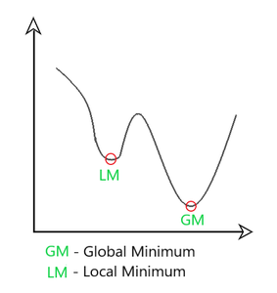  
Fig 3.11 Result of Adam optimizer

Here, we control the rate of gradient descent in such a way that there is minimum oscillation when it reaches the global minimum while taking big enough steps (step-size) so as to pass the local minima hurdles along the way. Hence, combining the features of the above methods to reach the global minimum efficiently.

### 3.6.3 MATHEMATICAL ASPECT OF ADAM OPTIMIZER

Taking the formulas used in the above two methods, we get $$m_{\left\{t\right\}}=β_{\left\{1\right\}m_{\left\{t-1\right\}}}+\left.\left(1-β_{\left(\left\{1\right\}\right.}\right)\right)\left.\left[\frac{δL}{δw_{\left\{t\right\}}}\right.\right]{,v}_{\left\{t\right\}}=β_{\left\{2\right\}v_{\left\{t-1\right\}}}+\left.\left(1-β_{\left(\left\{2\right\}\right.}\right)\right){\left.\left[\frac{δL}{δw_{\left\{t\right\}}}\right.\right]}^{\left\{2\right\}}$$

**Parameters Used :**

**1. ϵ =** a small +ve constant to avoid 'division by 0' error when (vt -> 0). (10-8)

**2. β1 & β2 =** decay rates of average of gradients in the above two methods. (β1 = 0.9 & β2 = 0.999)

**3. α —** Step size parameter / learning rate (0.001)

Since mt and vt have both initialized as 0 (based on the above methods), it is observed that they gain a tendency to be 'biased towards 0' as both β1 & β2 ≈ 1. This Optimizer fixes this problem by computing 'bias-corrected' mt and vt. This is also done to control the weights while reaching the global minimum to prevent high oscillations when near it. The formulas used are:

$$\hat{m_{\left\{t\right\}}}=\frac{m_{\left\{t\right\}}}{1-β_{\left\{1\right\}}^{\left\{t\right\}}}\hat{v_{\left\{t\right\}}}=\frac{v_{\left\{t\right\}}}{1-β_{\left\{2\right\}}^{\left\{t\right\}}}$$

Intuitively, we are adapting to the gradient descent after every iteration so that it remains controlled and unbiased throughout the process, hence the name Adam.

Now, instead of our normal weight parameters mt and vt , we take the bias-corrected weight parameters (m_hat)t and (v_hat)t. Putting them into our general equation, we get

$$w_{\left\{t+1\right\}}=w_{\left\{t\right\}}-\hat{m_{\left\{t\right\}}}\left.\left(\frac{α}{\sqrt{\hat{v_{\left\{t\right\}}}}+ε}\right.\right)$$

**Performance:**

Building upon the strengths of previous models, Adam optimizer gives much higher performance than the previously used and outperforms them by a big margin into giving an optimized gradient descent. The plot is shown below clearly depicts how Adam Optimizer outperforms the rest of the optimizer by a considerable margin in terms of training cost (low) and performance (high).

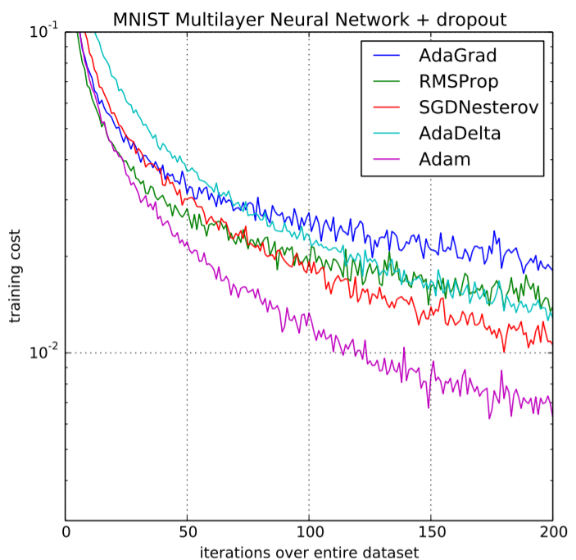

**Fig 3.12 Performance Comparison on Training cost**

## **3.7 CLASS WEIGHTS**

Most machine learning algorithms are not very useful with biased class data. But, we can modify the current training algorithm to take into account the skewed distribution of the classes. This can be achieved by giving different weights to both the majority and minority classes. The difference in weights will influence the classification of the classes during the training phase. The whole purpose is to penalize the misclassification made by the minority class by setting a higher class weight and at the same time reducing weight for the majority class

To be more precise**,**the formula to calculate this is:

wj=n_samples / (n_classes * n_samplesj)

Here,

* wj is the weight for each class(j signifies the class)
* n_samplesis the total number of samples or rows in the dataset
* n_classesis the total number of unique classes in the target
* n_samplesjis the total number of rows of the respective class

.

## **3.8 INTRODUCTION TO CONVOLUTIONAL NEURAL NETWORKS**

A convolutional neural network (CNN) is a specific type of artificial neural network that uses perceptrons, a machine learning unit algorithm, for supervised learning, to analyze data. CNNs apply to image processing, natural language processing and other kinds of cognitive tasks. A convolutional neural network is also known as a ConvNet.

Convolutional neural networks are neural networks used primarily to classify images (i.e. name what they see), cluster images by similarity (photo search), and perform object recognition within scenes. For example, convolutional neural networks (ConvNets or CNNs) are used to identify faces, individuals, street signs, tumors, platypuses and many other aspects of visual data.

LeNet was one of the very first convolutional neural networks which helped propel the field of Deep Learning. This pioneering work by Yann LeCun was named LeNet5 after many previous successful iterations since the year 1988 [3]. At that time the LeNet architecture was used mainly for character recognition tasks such as reading zip codes, digits, etc.

There are 4 main operation steps that exist in the ConvNet :

1. Convolution step
2. Non-Linearity step
3. Pooling or Sub Sampling step
4. Classification (Fully Connected Layer) step

The basic foundation of every Convolutional Neural Network is made up of these operations, so to develop a good understanding of these ConvNets, we need to comprehend thoroughly the working of these operations.

### 3.8.1 THE CONVOLUTION STEP

ConvNets derive their name from the “convolution” operator. The primary purpose of Convolution in case of a ConvNet is to extract features from the input image. Convolution preserves the spatial relationship between pixels by learning image features using small squares of input data. We will not go into the mathematical details of Convolution here, but will try to understand how it works over images.

Consider a 5 x 5 image whose pixel values are only 0 and 1 (note that for a grayscale image, pixel values range from 0 to 255, the green matrix below is a special case where pixel values are only 0 and 1) .

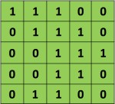

Also, consider another 3 x 3 matrix as shown below:

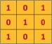

Then, the Convolution of the 5 x 5 image and the 3 x 3 matrix can be computed as shown in the figure below :

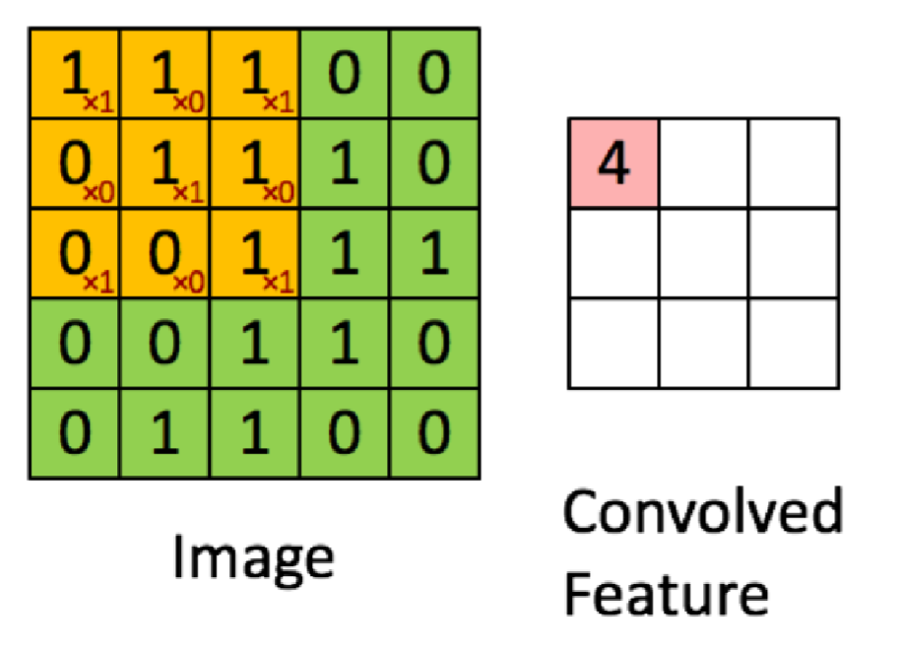

Fig 3.13 Convolution of 5x5 and 3x3 Matrices

Let’s understand how the computation above is being done. We slide the orange matrix over our original image (green) by 1 pixel (also called ‘stride’) and for every position, we compute element wise multiplication (between the two matrices) and add the multiplication outputs to get the final integer which forms a single element of the output matrix (pink). Note that the 3×3 matrix “sees” only a part of the input image in each stride.

In CNN terminology, the 3×3 matrix is called a ‘filter‘ or ‘kernel’ or ‘feature detector’ and the matrix formed by sliding the filter over the image and computing the dot product is called the ‘Convolved Feature’ or ‘Activation Map’ or the ‘Feature Map‘. It is important to note that filters acts as feature detectors from the original input image.

It is evident from the animation above that different values of the filter matrix will produce different Feature Maps for the same input image.

As an example, consider the following input image :

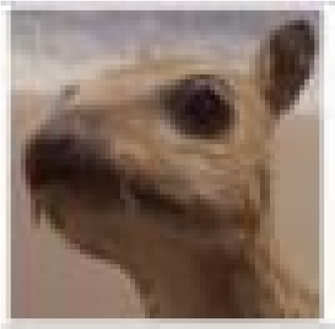

The effects of convolution of the above image with different filters. As shown, we can perform operations such as Edge Detection, Sharpen and Blur just by changing the numeric values of our filter matrix before the convolution operation.

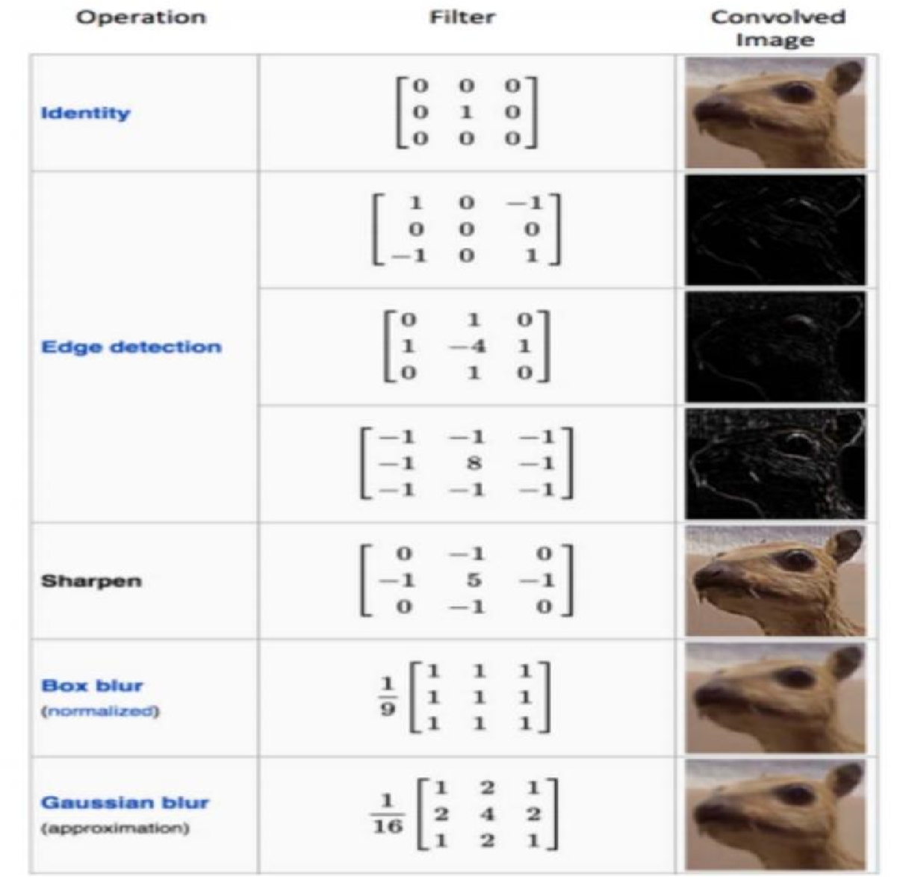

Fig 3.14 Different Effects of convolution

A filter (with red outline) slides over the input image (convolution operation) to produce a feature map. The convolution of another filter (with the green outline), over the same image gives a different feature map as shown. It is important to note that the Convolution operation captures the local dependencies in the original image. Also notice how these two different filters generate different feature maps from the same original image. Remember that the image and the two filters above are just numeric matrices as we have discussed above.

In practice, a CNN learns the values of these filters on its own during the training process (although we still need to specify parameters such as number of filters, filter size, architecture of the network etc. before the training process). The more number of filters we have, the more image features get extracted and the better our network becomes at recognizing patterns in unseen images.

The size of the Feature Map (Convolved Feature) is controlled by three parameters that we need to decide before the convolution step is performed.

* **Depth:** Depth corresponds to the number of filters we use for the convolution operation. In the network shown in Figure 7, we are performing convolution of the original boat image using three distinct filters, thus producing three different feature maps as shown. You can think of these three feature maps as stacked 2d matrices, so, the ‘depth’ of the feature map would be three.

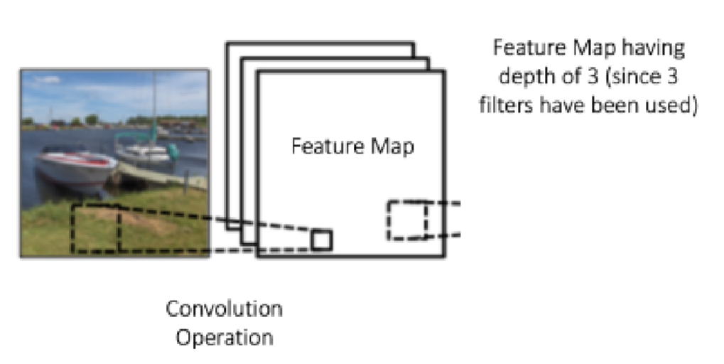

Fig 3.15 Convolutional Operation in feature map

* **Stride:** Stride is the number of pixels by which we slide our filter matrix over the input matrix. When the stride is 1 then we move the filters one pixel at a time. When the stride is 2, then the filters jump 2 pixels at a time as we slide them around. Having a larger stride will produce smaller feature maps.
* **Zero-padding:** Sometimes, it is convenient to pad the input matrix with zeros around the border, so that we can apply the filter to bordering elements of our input image matrix. A nice feature of zero padding is that it allows us to control the size of the feature maps. Adding zero-padding is also called wide convolution, and not using zero-padding would be a narrow convolution.

### 3.8.2 NON LINEARITY STEP

**1. ReLU Activation Function:**

ReLU stands for Rectified Linear Unit and is a non-linear operation. Its output is given by

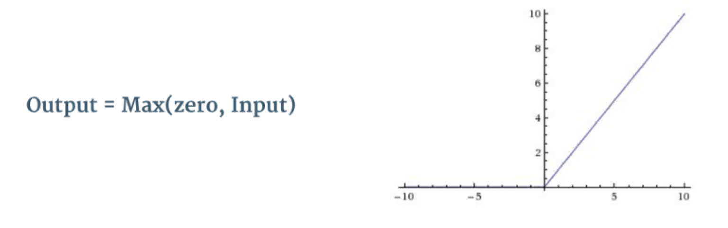

Fig 3.16 ReLU Operation

ReLU is an element wise operation (applied per pixel) and replaces all negative pixel values in the feature map by zero. The purpose of ReLU is to introduce non-linearity in our ConvNet, since most of the real-world data we would want our ConvNet to learn would be non-linear (Convolution is a linear operation – element wise matrix multiplication and addition, so we account for non-linearity by introducing a non-linear function like ReLU).

The ReLU operation can be understood clearly from Figure 9 below. It shows the ReLU operation applied to one of the feature maps obtained in Figure 6 above. The output feature map here is also referred to as the ‘Rectified’ feature map.

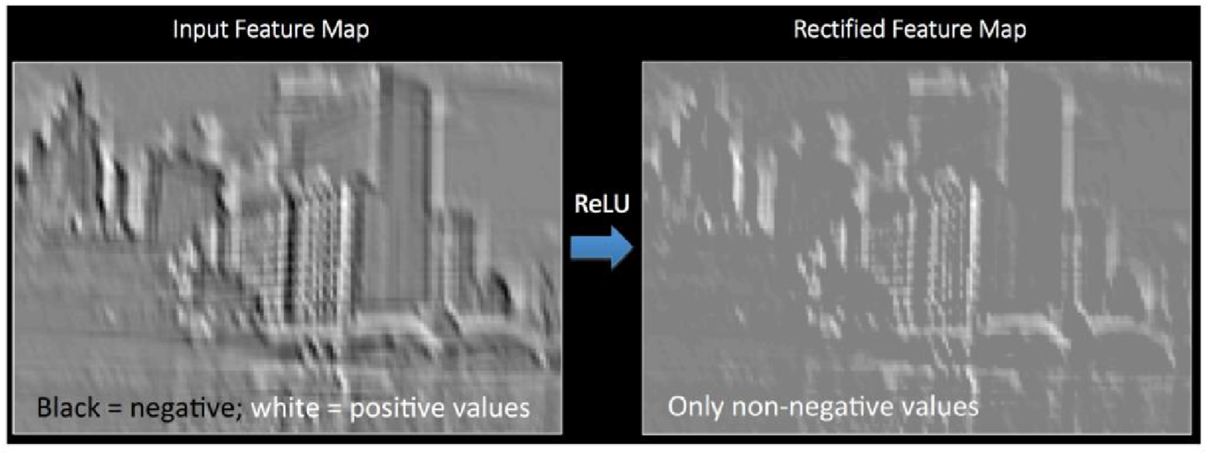

Fig 3.17 Rectified Feature Map

**2. Sigmoid or Logistic Activation Function:**

The Sigmoid Function curve looks like a S-shape.

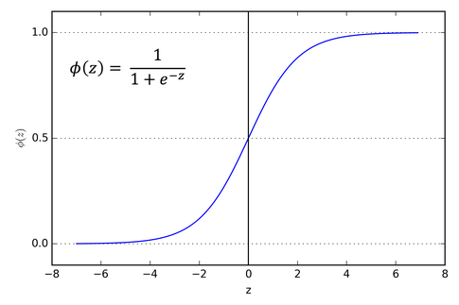

**Fig 3.18: Sigmoid Function**

The main reason why we use sigmoid function is because it exists between **(0 to 1).**Therefore, it is especially used for models where we have to **predict the probability** as an output.Since probability of anything exists only between the range of **0 and 1,** sigmoid is the right choice. The function is **differentiable**.That means, we can find the slope of the sigmoid curve at any two points.The function is **monotonic**but function’s derivative is not. . The logistic sigmoid function can cause a neural network to get stuck at the training time.The **softmax function** is a more generalized logistic activation function which is used for multiclass classification.

### 3.8.3 POOLING STEP

Spatial Pooling (also called subsampling or downsampling) reduces the dimensionality of each feature map but retains the most important information. Spatial Pooling can be of different types: Max, Average, Sum etc.

In case of Max Pooling, we define a spatial neighborhood (for example, a 2×2 window) and take the largest element from the rectified feature map within that window. Instead of taking the largest element we could also take the average (Average Pooling) or sum of all elements in that window. In practice, Max Pooling has been shown to work better.

Figure below shows an example of Max Pooling operation on a Rectified Feature map (obtained after convolution + ReLU operation) by using a 2×2 window.

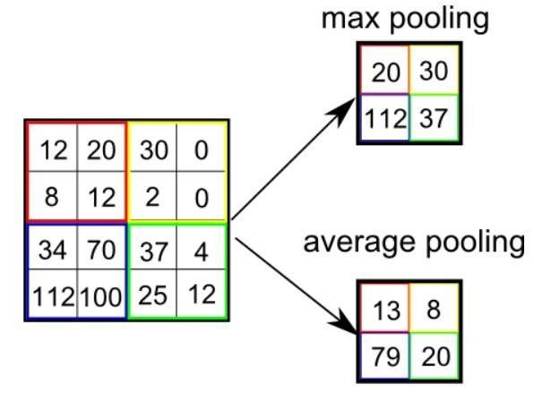

Fig 3.19 Pooling Operation

We slide our 2 x 2 window by 2 cells (also called ‘stride’) and take the maximum value in each region. As shown in above Figure, this reduces the dimensionality of our feature map. In the network shown in below figure, pooling operation is applied separately to each feature map (notice that, due to this, we get three output maps from three input maps).

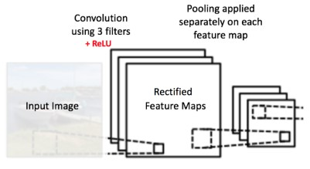

Fig 3.20 Input Maps

The function of Pooling is to progressively reduce the spatial size of the input representation. In particular, pooling

* makes the input representations (feature dimension) smaller and more manageable
* reduces the number of parameters and computations in the network, therefore, controlling overfitting
* makes the network invariant to small transformations, distortions and translations in the input image. A small distortion in input will not change the output of Pooling – since we take the maximum / average value in a local neighborhood.
* helps us arrive at an almost scale equivariant representation of our image, this is very powerful since we can detect objects in an image no matter where they are.

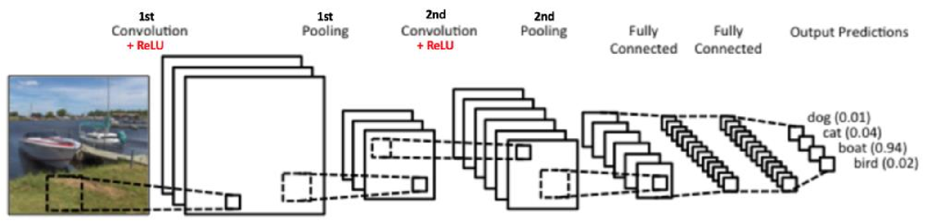

Fig 3.21 ConvNet Architecture

It is important to understand that these layers are the basic building blocks of any CNN. As shown in figure, we have two sets of Convolution, ReLU & Pooling layers – the 2nd Convolution layer performs convolution on the output of the first Pooling Layer using six filters to produce a total of six feature maps. ReLU is then applied individually on all of these six feature maps. We then perform Max Pooling operation separately on each of the six rectified feature maps.

Together these layers extract the useful features from the images, introduce non-linearity in our network and reduce feature dimension while aiming to make the features somewhat equivariant to scale and translation .

### 3.8.4 CLASSIFICATION PART (FULLY CONNECTED LAYER)

The Fully Connected layer is a traditional Multi Layer Perceptron that uses a softmax activation function in the output layer ,other classifiers like SVM can also be used, but will stick to softmax. The term “Fully Connected” implies that every neuron in the previous layer is connected to every neuron on the next layer.

The output from the convolutional and pooling layers represent high-level features of the input image. The purpose of the Fully Connected layer is to use these features for classifying the input image into various classes based on the training dataset. For example, the image classification task we set out to perform has four possible outputs as shown in Figure below :

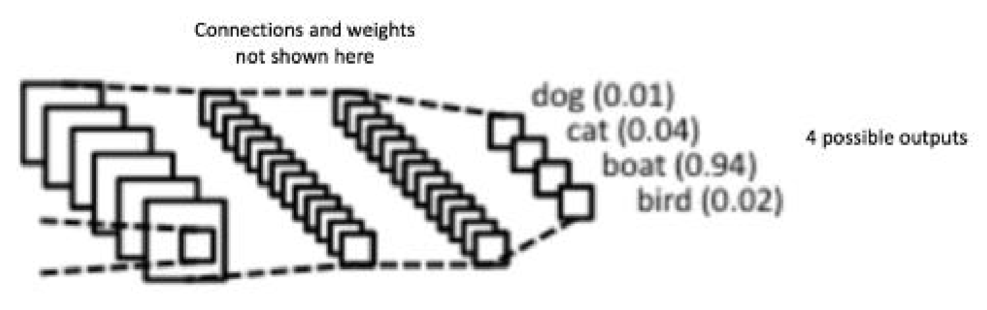

Fig 3.22 Fully connected Network

Apart from classification, adding a fully-connected layer is also a cheap way of learning nonlinear combinations of these features. Most of the features from convolutional and pooling layers may be good for the classification task, but combinations of those features might be even better.

The sum of output probabilities from the Fully Connected Layer is 1. This is ensured by using the Softmax as the activation function in the output layer of the Fully Connected Layer. The Softmax function takes a vector of arbitrary real-valued scores and squashes it to a vector of values between zero and one that sum to one.

Other Layers in CNN :

### 3.8.5 DROPOUT LAYER

"Dropout layer" can help correct overfitting.

Overfitting is caused by the network learning spurious patterns in the training data. To recognize these spurious patterns a network will often rely on very a specific combinations of weight, a kind of "conspiracy" of weights. Being so specific, they tend to be fragile: remove one and the conspiracy falls apart. This is the idea behind **dropout**. To break up these conspiracies, we randomly drop out some fraction of a layer's input units every step of training, making it much harder for the network to learn those spurious patterns in the training data. Instead, it has to search for broad, general patterns, whose weight patterns tend to be more robust.

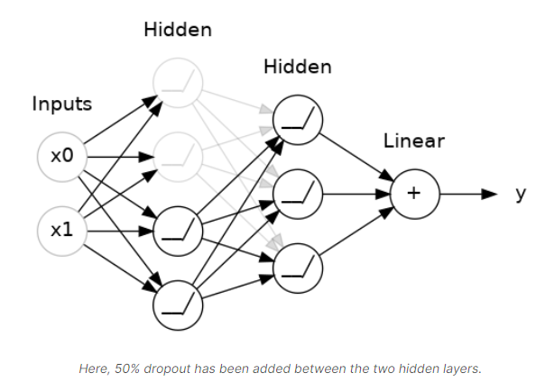

Fig 3.23 Drop Out

### 3.8.6 BATCH NORMALIZATION LAYER

The next special layer we'll look at performs "batch normalization" (or "batchnorm"), which can help correct training that is slow or unstable.

With neural networks, it's generally a good idea to put all of your data on a common scale. The reason is that SGD will shift the network weights in proportion to how large an activation the data produces. Features that tend to produce activations of very different sizes can make for unstable training behavior.

Now, if it's good to normalize the data before it goes into the network, maybe also normalizing inside the network would be better! In fact, we have a special kind of layer that can do this, the **batch normalization layer**. A batch normalization layer looks at each batch as it comes in, first normalizing the batch with its own mean and standard deviation, and then also putting the data on a new scale with two trainable rescaling parameters. Batchnorm, in effect, performs a kind of coordinated rescaling of its inputs.

Most often, batchnorm is added as an aid to the optimization process (though it can sometimes also help prediction performance). Models with batchnorm tend to need fewer epochs to complete training. Moreover, batchnorm can also fix various problems that can cause the training to get "stuck".

### 3.8.7 DENSE LAYER

Dense layer is the regular deeply connected neural network layer. It is most common and frequently used layer. Dense layer does the below operation on the input and return the output.

output = activation(dot(input, kernel) + bias)

where,

* **input** represent the input data
* **kernel** represent the weight data
* **dot** represent numpy dot product of all input and its corresponding weights
* **bias** represent a biased value used in machine learning to optimize the model
* **activation** represent the activation function.

## **3.9 TRAINING PHASE**

**Example :**

since the input image is a boat, the target probability is 1 for Boat class and 0 for other three classes,

* Input Image = Boat
* Target Vector = [0, 0, 1, 0]

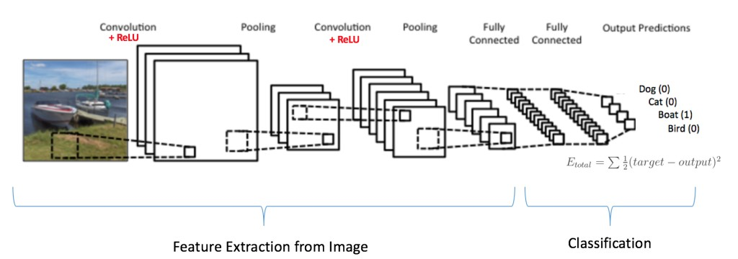

Fig 3.24 Training the ConvNet

The overall training process of the Convolution Network may be summarized as below:

**Step 1:** We initialize all filters and parameters / weights with random values

**Step 2:** The network takes a training image as input, goes through the forward propagation step (convolution layer, ReLU layer , pooling layer,batch normalization layer,drop layer,dense layer actions along with forward propagation in the Fully Connected layer) and finds the output probabilities for each class.

Let’s say the output probabilities for the boat image above are [0.2, 0.4, 0.1, 0.3]

Since weights are randomly assigned for the first training example, output probabilities are also random.

**Step 3:** Calculate the total error at the output layer

**Step 4:** Use Backpropagation to calculate the gradients of the error with respect to all weights in the network and use gradient descent(Adam optimizer) to update all filter values / weights and parameter values to minimize the output error.

The weights are adjusted in proportion to their contribution to the total error.

When the same image is input again, output probabilities might now be [0.1, 0.1, 0.7, 0.1], which is closer to the target vector [0, 0, 1, 0].

This means that the network has learnt to classify this particular image correctly by adjusting its weights / filters such that the output error is reduced.

Parameters like number of filters, filter sizes, architecture of the network etc. have all been fixed before Step 1 and do not change during training process – only the values of the filter matrix and connection weights get updated.

**Step5:** Repeat steps 2-4 with all images in the training set.

The above steps train the ConvNet – this essentially means that all the weights and parameters of the ConvNet have now been optimized to correctly classify images from the training set.

## **3.10 TESTING PHASE**

When a new (unseen) image is input into the ConvNet, the network would go through the forward propagation step and output a probability for each class (for a new image, the output probabilities are calculated using the weights which have been optimized to correctly classify all the previous training examples).

If our training set is large enough, the network will (hopefully) generalize well to new images and classify them into correct categories.

## **3.11 VOTING**

When trying to classify an input image, more CNN models will be used, each of them voting three labels, based on prediction accuracy. In order for the label to be voted, the accuracy should be greater than a given threshold, by default 90%. The label with the greatest sum is the winner, if there exists one.

# Chapter-4

**DETECTION METHODOLOGY**

# 4. DETECTION METHODOLOGY

The image is first preprocessed, so that the signs can be detected more easily, in a geometric manner.

* Preprocessing consists of

## **4.1 CONTRAST**

* **Contrast** is the difference in luminance or color that makes an object (or its representation in an image or display) distinguishable. In visual perception of the real world, contrast is determined by the difference in the color and brightness of the object and other objects within the same field of view.
* The human visual system is more sensitive to contrast than absolute luminance; we can perceive the world similarly regardless of the huge changes in illumination over the day or from place to place. The maximum contrast of an image is the contrast ratio or dynamic range.
* enhancing the contrast, so that colors can be recognized more easily;

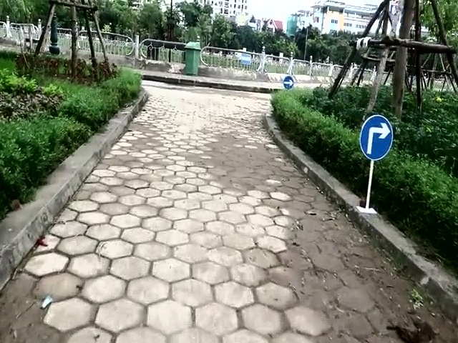

Fig 4.1 Contrast

## **4.2 MASKING/FILTERING**

* Image masking is the process of separating an image from its background, either to cause the image to stand out on its own or to place the image over another background.
* In the old days of film stripping, it was done by cutting a physical "mask"--a sheet of material such as rubylith--in the shape of the image, and then projecting the image through it.

Filtering the image in such a manner that only colors that may represent a traffic sign remain, the rest being faded to black;

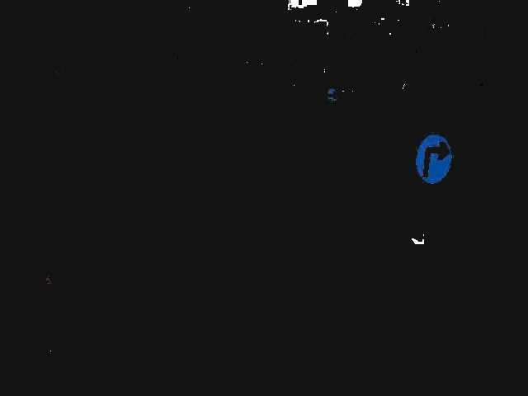

Fig 4.2 Masking

## **4.3 CANNY EDGE DETECTION**

Applying the canny edge detection algorithm;

Canny Edge Detection is a popular edge detection algorithm. It was developed by John F. Canny .

1. It is a multi-stage algorithm and we will go through each stages.
2. Noise Reduction

Since edge detection is susceptible to noise in the image, first step is to remove the noise in the image with a 5x5 Gaussian filter.

The equation for a Gaussian filter kernel of size (2*k*+1)×(2*k*+1) is given by:

{\displaystyle H_{ij}={\frac {1}{2\pi \sigma ^{2}}}\exp \left(-{\frac {(i-(k+1))^{2}+(j-(k+1))^{2}}{2\sigma ^{2}}}\right);1\leq i,j\leq (2k+1)}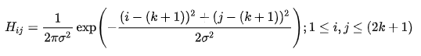

Here is an example of a 5×5 Gaussian filter

{\displaystyle \mathbf {B} ={\frac {1}{159}}{\begin{bmatrix}2&4&5&4&2\\4&9&12&9&4\\5&12&15&12&5\\4&9&12&9&4\\2&4&5&4&2\end{bmatrix}}*\mathbf {A} .}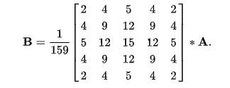

It is important to understand that the selection of the size of the Gaussian kernel will affect the performance of the detector. The larger the size is, the lower the detector's sensitivity to noise. Additionally, the localization error to detect the edge will slightly increase with the increase of the Gaussian filter kernel size. A 5×5 is a good size for most cases, but this will also vary depending on specific situations.

1. Finding Intensity Gradient of the Image

Smoothened image is then filtered with a Sobel kernel in both horizontal and vertical direction to get first derivative in horizontal direction ( Gx) and vertical direction ( Gy). From these two images, we can find edge gradient and direction for each pixel as follows:

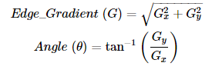

The templates for the Sobel operator can be found in Figure.

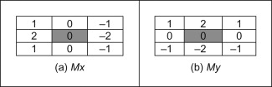

Fig 4.3 Sobel operator

Gradient direction is always perpendicular to edges. It is rounded to one of four angles representing vertical, horizontal and two diagonal directions

.

1. Non-maximum Suppression

After getting gradient magnitude and direction, a full scan of image is done to remove any unwanted pixels which may not constitute the edge. For this, at every pixel, pixel is checked if it is a local maximum in its neighborhood in the direction of gradient. Check the image below:

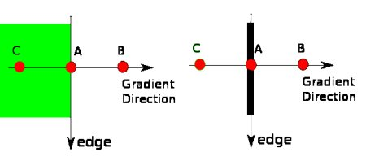

Point A is on the edge ( in vertical direction). Gradient direction is normal to the edge. Point B and C are in gradient directions. So point A is checked with point B and C to see if it forms a local maximum. If so, it is considered for next stage, otherwise, it is suppressed ( put to zero).

In short, the result you get is a binary image with "thin edges".

1. Hysteresis Thresholding

This stage decides which are all edges are really edges and which are not. For this, we need two threshold values, minVal and maxVal. Any edges with intensity gradient more than maxVal are sure to be edges and those below minVal are sure to be non-edges, so discarded. Those who lie between these two thresholds are classified edges or non-edges based on their connectivity. If they are connected to "sure-edge" pixels, they are 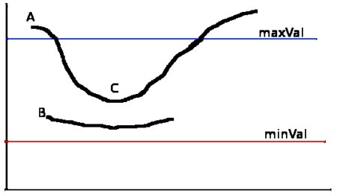

Fig 4.4 Threshold values for edge detection

considered to be part of edges. Otherwise, they are also discarded. See the image below:

The edge A is above the maxVal, so considered as "sure-edge". Although edge C is below maxVal, it is connected to edge A, so that also considered as valid edge and we get that full curve. But edge B, although it is above minVal and is in same region as that of edge C, it is not connected to any "sure-edge", so that is discarded. So it is very important that we have to select minVal and maxVal accordingly to get the correct result.

This stage also removes small pixels noises on the assumption that edges are long lines.

So what we finally get is strong edges in the image.

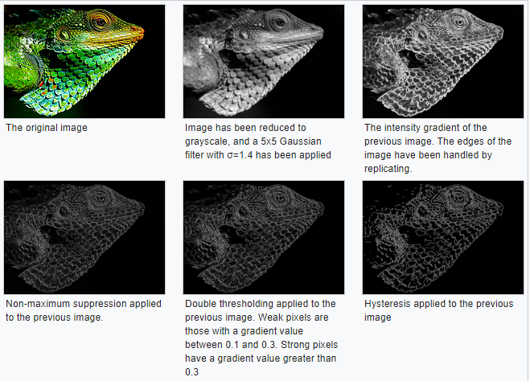

Fig 4.5 Example of Canny Edge Algorithm

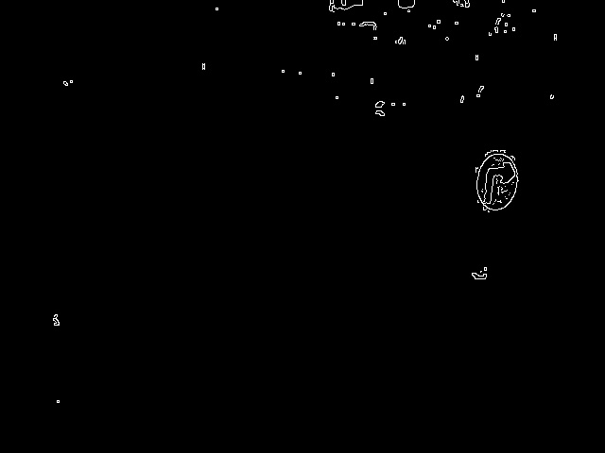

Fig 4.6 output of canny edge algorithm

## **4.4 BINARIZATION.**

Image binarization is the process of taking a grayscale image and converting it to black-and-white, essentially reducing the information contained within the image from 256 shades of gray to 2: black and white, a binary image.

finally binarizing the image.



Fig 4.7 Binarization

## **4.5 REMOVAL OF SMALL COMPONENTS**

After the image was preprocessed, the small components are removed

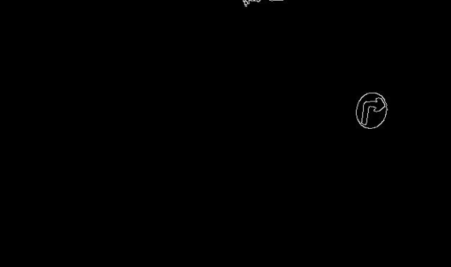

Fig 4.8 Removal of Small Components

* 1. **CONTOUR HANDLING**

Contours handling is a process can be explained simply as a curve joining all the continuous points (along with the boundary), having same color or intensity. The contours are a useful tool for shape analysis and object detection and recognition.

All the external contours are found and the sign having the greatest distance from its center to the contour is extracted from the image.

We Used Border Following Algorithm of Satoshi Suzuki and KeiichiA [10] for contour detection.

THE BORDER FOLLOWING ALGORITHM - This extracts the surroundness relation among the borders of a binary picture.

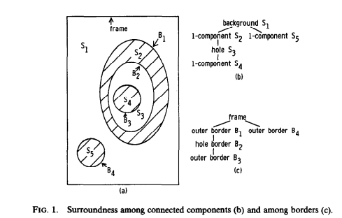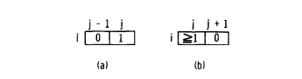

Fig. 4.9. The conditions of the border following staring point (i, j) for an outer border (a) and a hole border (b).

ALGORITHM -1. Scan an input binary picture with a TV raster and interrupt the raster scan when a pixel (i, j) is found which satisfies the condition for the border following starting point of either an outer border (Fig. 4.9a) or a hole border (Fig. 4.9b).

If the pixel (i, j) satisfies both of the above conditions, (i, j) must be regarded as the starting point of the outer border.

Assign a uniquely identifiable number to the newly found border. Let us call it the sequential number of the border and denote it by NBD.

Determine the parent border of the newly found border as follows. During the raster scan we also keep the sequential number LNBD of the (outer or hole) border encountered most recently. This memorized border should be either the parent border of the newly found border or a border which shares the common parent with the newly found border.

Therefore, we can decide the sequential number of the parent border of the newly found border with the types of the two borders according to Table 1.The distinguished feature of our algorithm is the marking policy.

(a) If the current following border is between the 0-component which contains the pixel ( p, q + 1) and the l-component which contains the pixel ( p, q), change the value of the pixel (p, q) to -NBD.

(b) Otherwise, set the value of the pixel (p, q) to NBD unless (p, q) is on an already followed border.

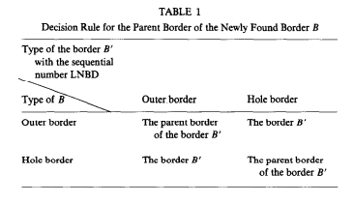

TABLE 1 Decision Rule for the Parent Border of the Newly Found Border B

The conditions (a) and (b) prohibit the pixel ( p, q) from being the border following starting points of the already followed hole border and outer border, respectively.

After following and marking the entire border, resume the raster scan. When the scan reaches the lower right comer of the picture, the algorithm stops.

Let us explain the process of the algorithm by an example depicted in Fig. 4.10.

The input binary picture is given in (a). When the raster scan reaches the circled l-pixel, we find that it satisfies the condition for the starting point of an outer border (Fig. 4.9a). The sequential number 2 is assigned to the border, because the number 1 is set aside for the frame of the picture.

We also find out from Table 1 that its parent border is the frame.

Then the border following starts and all the pixel values on that border are changed to either 2 or - 2, as shown in (b). After following the entire border, raster scan resumes.

The next border following starts at the circled pixel in (b), which satisfies the condition for the starting point of a hole border (Fig. 4.9b).

Note that a point having a negative value cannot be a starting point of border following.

The parent border of this border (with the number 3) is found to be the outer border with the number 2. During the border following, two pixels with value 2 are changed to - 3 by the marking policy (a), and two pixels with value 1 are changed to 3 by the policy (b).

All the other already visited pixels (with value 2) are unchanged. The steps go on in a similar manner and we obtain the final results (e)

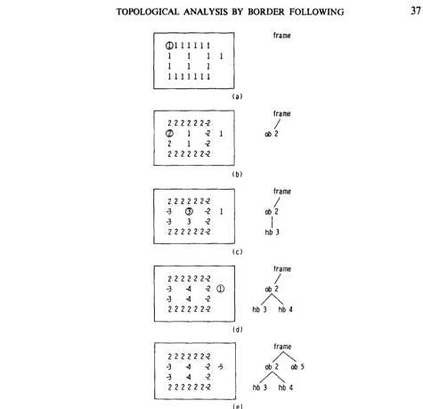

Fig 4.10 An illustration of the process of Algorithm 1. The left-hand figures show the pixel values and the right-hand the extracted structures among borders(ob:outer border,hb:hole border).The circled pixels are the starting points of border following.

THE BORDER FOLLOWING ALGORITHM FOR EXTRACTING ONLY THE OUTERMOST BORDERS We can modify the algorithm shown above so that it follows only the outermost borders of a binary picture (i.e., the outer border between the background and a l-component).

ALGORITHM 2. We explain here only the difference of the algorithm from Algorithm 1.

(1) We start the border following only at the points such that the condition for the border following starting point of an outer border (Fig. 4.9a) holds and LNBD <= 0 when the raster scan reaches there.

(2) The marking policy is the same as that of Algorithm 1 except that the values “2” and “ -2” are substituted for the values “NBD” and “-NBD,” respectively.

(3) We keep the value LNBD of the nonzero pixel encountered most recently during the raster scan. Every time we begin to scan a new row of the picture, reset LNBD to zero.

The rationale for Algorithm 2 is as follows. The parent border of an outermost border is the frame of the picture. Therefore, the border point (i, j) immediately at the right of a O-pixel is on an outermost border if and only if (i, j) satisfies either of the following conditions (1) or (2).

(1) All the pixels (i, l), (i, 2), . . . , (i, j - 1) are O-pixels.

(2) The border point (i, h) which has been encountered most recently during the TV raster scan is on an outer border and the pixel (i, h + 1) belongs to the background.

Since we kept the value LNBD of the nonzero pixel encountered most recently during the TV raster scan, the above conditions (1) and (2) can be checked by the conditions “LNBD = 0” and “LNBD = -2,” respectively, without following the other borders than the outermost ones.

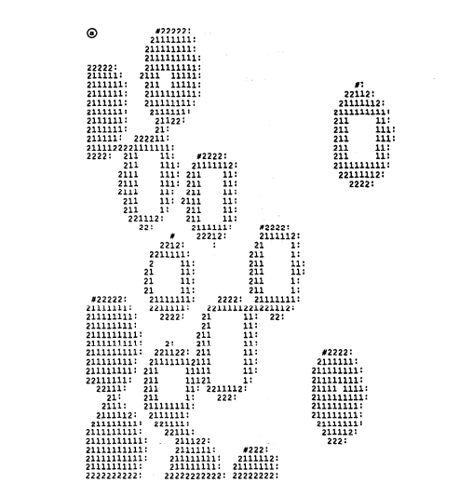

Fig 4.11 The results of shrinking blobs (a) and line patterns (b) by Algorithm 2.”#” represents the border following starting point of and outermost border ,”:” denotes -2

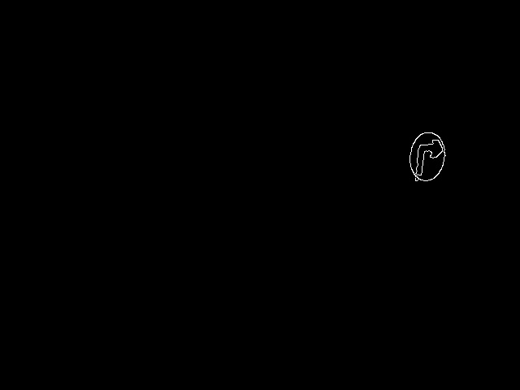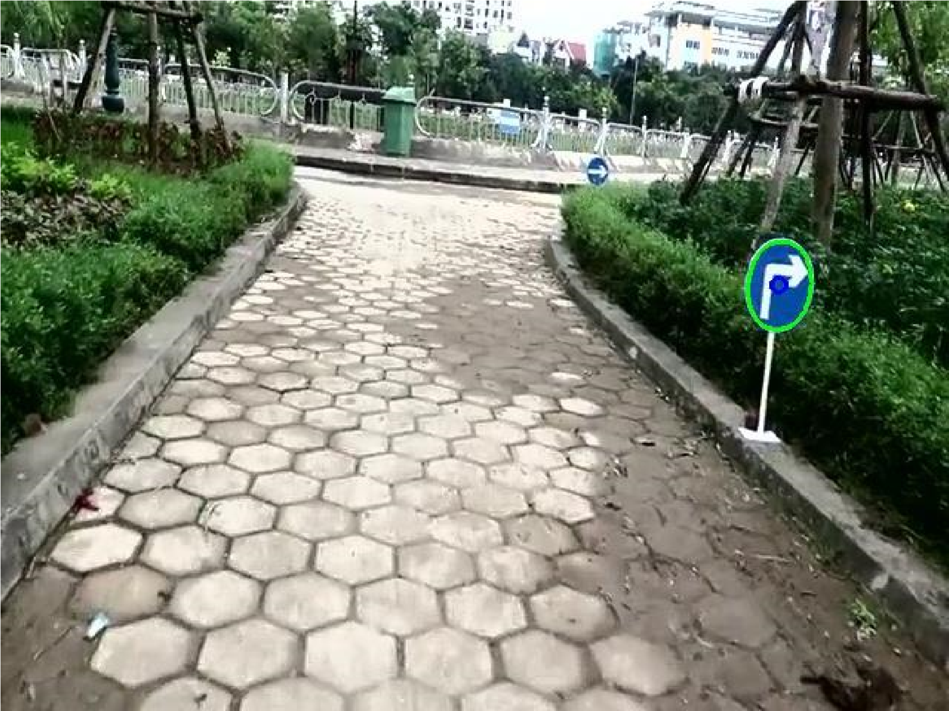

Fig 4.12 contour handling

* 1. **CROP**

Finally, a square image is cropped, based on the sign’s contour.

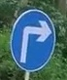

Fig 4.13 cropped image

# Chapter-5

**ALGORITHM DESCRIPTION**

# 5. ALGORITHM DESCRIPTION

Complete system architectures has been represented below. The main algorithm is divided into two parts, testing and training. First, we need to train the networks to classify the given Traffic Sign. The first step of our algorithm is to check whether the trained data are present or not. If not, then we need to train the system first and then we can perform testing for Traffic Sign classification.

### 5.1 PROPOSED ALGORITHMS

**Step 1**: If (trained database is not available)

**Step 2**: Load the training datasetGerman Traffic Sign(i.e Train.csv and Test.csv).

Preprocess the images(i.e Resize , Contrast Limited Adaptive Histogram Equalization(CLAHE)).

**Step 3**:Split training data again into Training and Final Evaluation/Validation – Disjoint.

**Step 4:**Scale the input(trainX,testX) to [0,1].Convert the class vector

(integers)(trainY,testY) to binary class matrix.

**Step 5**:Calculate Class Weights.Construct image generator for data Augmentation.

**Step 6**: Intialize the optimizer(Adam)

**Step 7:** Run Algorithm 2

**Step 8:** Save trained model

**Step 5:**Repeat Step 1 to Step 8 for the three CNN’s.

**Step 5:** Else (load trained database for the three CNN’s)

**Step 6:** Get input image/video from system folder/Google Drive

**Step 7:** Run Algorithm1 (Detect Traffic Sign, crop and save it for recognition)

**Step 8:** Run Algorithm3(Use trained models to predict traffic sign)

**Step 9** : (Result 1) Display the input image/video with bounding box around Traffic Sign

**Step 10 :** (Result 2) Display the label of traffic sign on the testing image/video.

#### **5.1.1 Algorithm 1: Detection :**

**Step 1**: Get input(image/video) from user.

**Step 2:** The input is first preprocessed (like contrast , color filtering , canny edge detection , binarizing) , so that the signs can be detected more easily.

**Step 2:** The small components are removed, all the external contours are found.

**Step 3:** Taking maximum area Traffic-sign among all Traffic-signs.

**Step 4:** Crop the selected maximum area Traffic-sign from image.

The majority of the algorithms are implemented by default in the cv2 library in Python.

a) Contrast –

* The image is first converted to YCrCb colorspace, consisting of Y - luminance or Luma, Cr - how far Luma is from the red component and Cb - how far Luma is from the blue component.
* Then the histogram of the Luma is equalized, spreading out the values from any cluster, and finally, the image is converted back to RGB.

b) Color Filtering –

* The image is converted to HSV color space at first. Then 5 masks, meaning images where only black and a color ranging between some given values, are obtained.
* The masks correspond to red, white, blue and white.
* Two masks are obtained for the color red as, the HSV color space being a circular one, red’s range is present on the upper, as well as on the lower boundary.
* Finally, the masks are combined.

c)Canny Edge Detection-

* This step is done with the classical Canny algorithm, by first reducing the noise with a Gaussian filter.
* Then the intensity gradient is found for each pixel, all the pixels that are not local maximums being removed afterwards.
* Thresholding is then considered, based on two dynamic values, computed using the median of the image.
* Finally, only hard edges are obtained.

The final part of preprocessing is converting the image to binary, leaving only black and white. After this, all the small components are removed by finding if their sizes, found through analyzing connected components, are below a given threshold.

d)Contour Handling –

* Contours can be found easily on the obtained images by using the cv2 function called findContours().
* To find out if the contour really is a sign, its signature is compared to that of a circle.( The signature is found by dividing the distance from the center to each point of the contour to the maximum found distance, and averaging them.)
* If the threshold to which the value is compared is high enough, it will work for triangles and diamonds too, as all the signs are symmetric.
* Only the largest signs is cropped out of the image and passed on to classification.

#### **5.1.2 Algorithm 2: Deep Convolutional Neural Network :**

**Step 1:**Initialize Hyperparameters (Learning rate , Batch size , No of Epochs)

**Step 2**:We initialize all filters and weights with random values.

**Step 3**:Compile the model with required optimizer(Adam),Loss(binary cross_entropy)and the metrics(Accuracy) to be calculated.

**Step 4 :** The training image is input to the network and goes over the forward propagation phases (i.e. convolution layer, ReLU layer , pooling layer,batch normalization layer,drop layer,dense layer actions along with forward propagation in the Fully Connected layer) and gives output probabilities for all class.

Let’s assume the output probabilities for the first given image are [0.4, 0.2, 0.3, 0.5, 0, 0, 0]. Since weights are randomly assigned for the first training image, therefore output probabilities are also random.

**Step 5:** Calculating the error(binary cross_entropy) at the output layer is given as Total Error

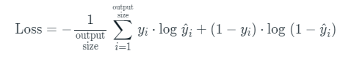

**Step 6:** Using Back propagation we compute the gradients of the error for all weights in the network and use gradient descent to update all filter values / weights and parameter values to minimize the output error. The weights are updated in proportion to put their influence to reducing the error. When the same image is imputed again, output probabilities might now be [0.1, 0.1, 0.8, 0.1, 0, 0, 0] which is closer to the target vector [0, 0, 1, 0, 0, 0, 0]. This implies now the network has learnt to categorize this particular picture correctly by altering its weights / filters, so that the output error is reduced. Factors like architecture of the network, number of filters used, filter sizes etc. have all been fixed before Step 1 and do not change during training process – only the values of the filter matrix and connection weights search out updated during the process.

#### **5.1.3 Algorithm 3:Voting**

**Step 1:** Loaded CNN models will be used, each of them voting three labels, based on prediction accuracy.

**Step 2**:In order for the label to be voted, the accuracy should be greater than a given threshold, by default 90%.

**Step 3:** The label with the greatest sum is the winner, if there exists one

## **5.2 FLOWCHART**

### 5.2.1 TRAINING AND TESTING FLOWCHART:

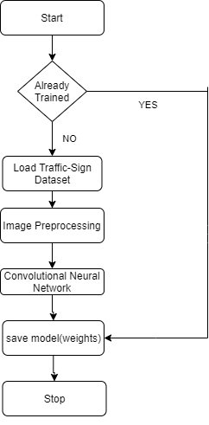 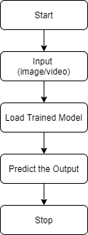

Fig 5.1 Training flowchart Fig 5.2 Testing Flowchart

**5.2.2 DETECTION AND RECONCILIATION FLOWCHART**

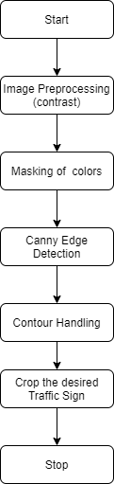 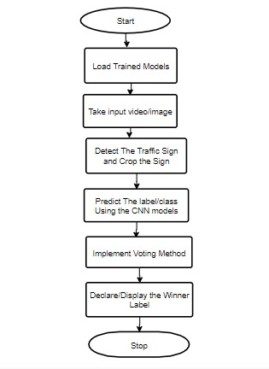

Fig 5.3 Detection Flowchart Fig 5.4 Reconciliation/Reunion Flowchart

**5.3 ARCHITECTURE OF MODELS**

**Model 1:**

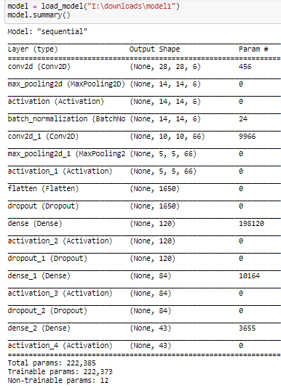

Fig 5.5 Architecture of model-1

**Model 2:**

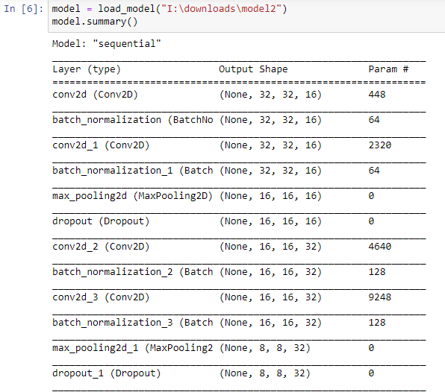

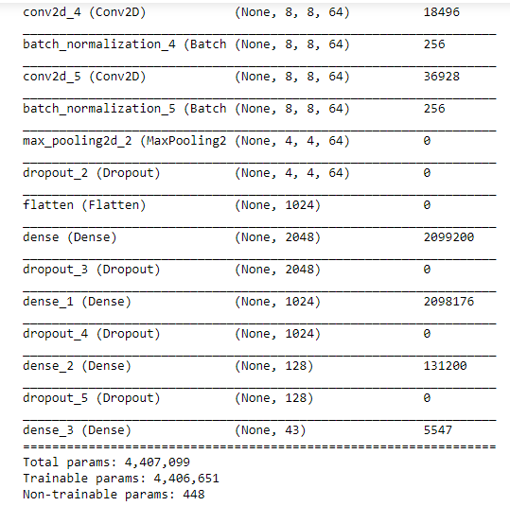

Fig 5.6 Architecture of Model-2

**Model3:**

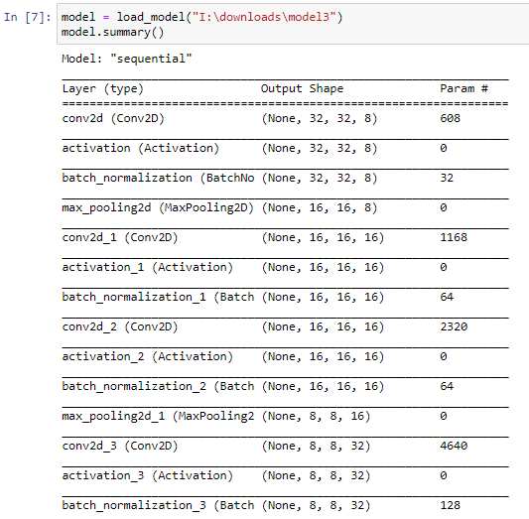

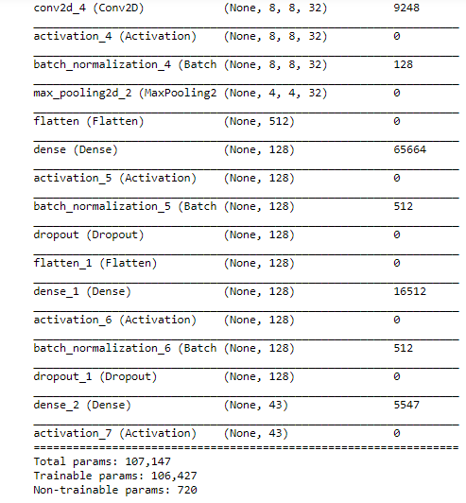

Fig 5.7 Architecture of Model-3

# Chapter-6

**RESULT**

# 6. RESULTS

## **6.1 Detection**

Detection was done as explained in proposed Solution. It works well most of the time, but it can become faulty, as it depends on illumination and the whole scene. There are cases when the algorithm doesn’t detect any sign due to it being oddly illuminated. In other cases, the algorithm prefers to yield a different object to the detriment of a sign, due to it begin closer and having the right colors.

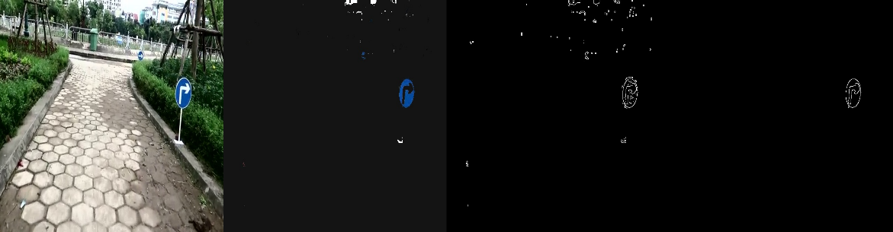

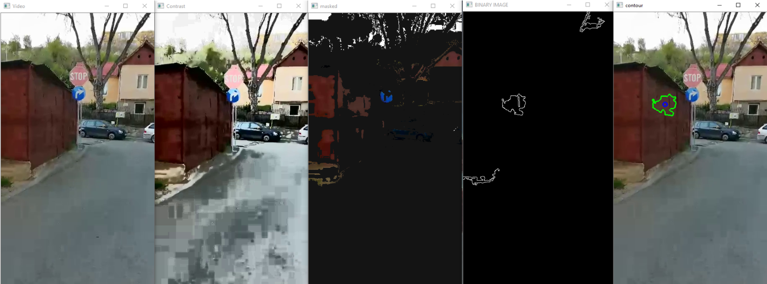Figure 6.1 presents visually the way an image is processed, including contrasting, masking, canny-edge detection and small parts removal.

Figure 6.2, on the other hand, displays an erroneous course the pipeline may take, due to illumination.

This erroneous findings, however, will be filtered in most cases by the classifiers, obtaining low likeliness and not being voted.

## **6.2 Classification**

### 6.2.1 Model-1 CLASSIFICATION REPORT

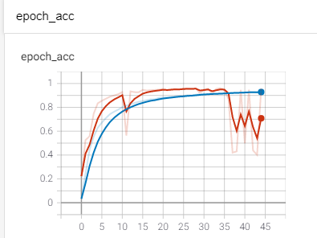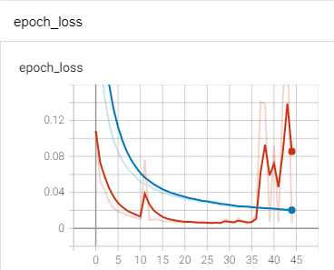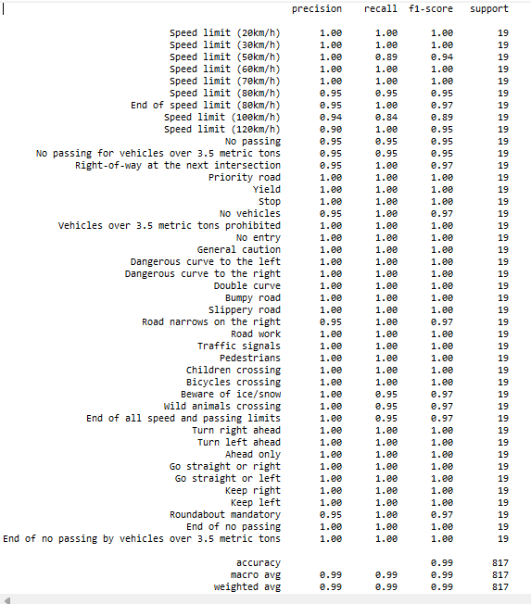

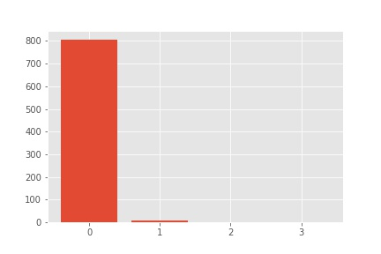

Fig 6.3 Evaluation total statistics (0 - recognized first choice; 1 - second choice; 2 - third choice; 3 - others [unrecognized])

### 6.2.1 Model-2 CLASSIFICATION REPORT

****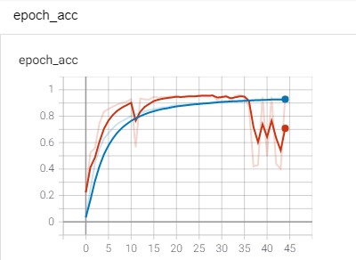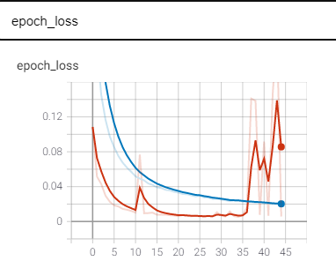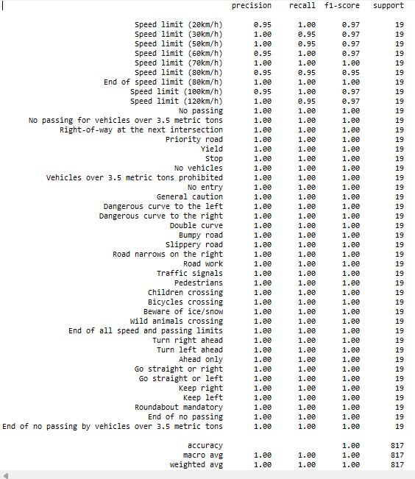

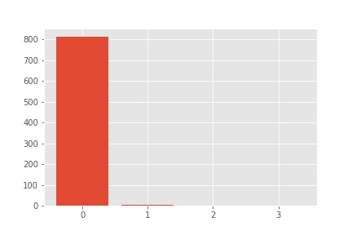

Fig 6.4 Evaluation total statistics (0 - recognized first choice; 1 - second choice; 2 - third choice; 3 - others [unrecognized])

### 6.2.3 Model-3 CLASSIFICATION REPORT

****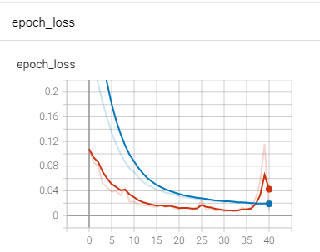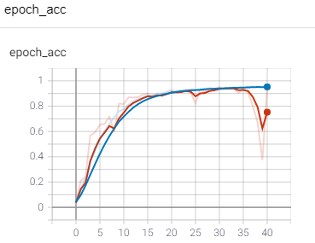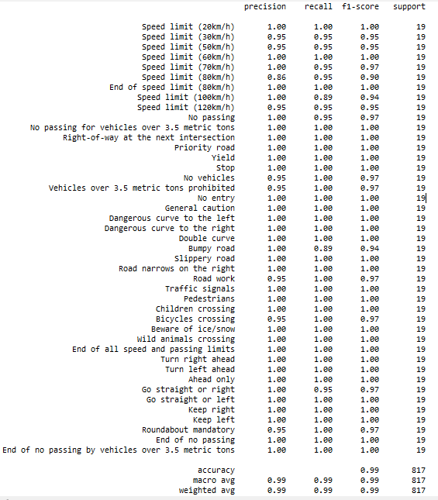



Fig 6.5 Evaluation total statistics (0 - recognized first choice; 1 - second choice; 2 - third choice; 3 - others [unrecognized])

# 7. Conclusion

In this project, a traffic sign recognition system, divided into two parts, was presented. The first part is based on classical image processing techniques, for traffic signs extraction out of a video/image, whereas the second part is based on machine learning, more explicitly, convolutional neural networks, for image labeling.

When put together, the two parts work well, as the majority of the erroneous data sent by the detector is rejected by the classifier. Voting certainly helps, as more models that behave differently can classify an image and come up with the best statistical result.

In Night conditions with flash or headlight illumination seem to be the best. The combination of low ambient noise due to lack of ambient light and the high visibility of the sign due to the reflected light makes the detector’s job, and, as a result, the classifier’s job too, very easy.

In Shade conditions , the project yield good results, as color is not de-natured and the masks do not cover the signs. The classifier has to reject a moderate amount of noise, most commonly rocks, a very clear blue sky or blue cars, and some patches of grass.

In Intense light conditions makes the detector skip some signs, their colors being denatured and, as a result, masked by the color mask. In that case, the classifier has no power, being able only to reject the noise it is fed with.

An improvement that can be brought to classification is a new class, consisting of different kinds of objects that are not traffic signs, so that the models may know how to handle noise better. This would be an alternative to using sigmoid.

Detection can be done using machine learning as well. Architectures like YOLO can detect and crop images from videos, as well as classify objects in those images, with outstanding speed.

# REFERENCES:

[1]Arturo de la Escalera, Luis Moreno, Miguel Salichs, and J.M. Armingol. Road traffic sign detection and classification. *Industrial Electronics, IEEE Transactions on*, 6:848 – 859, 12 1997.

[2]A Method for Traffic Sign Recognition with CNN using GPU Alexander Shustanov and Pavel Yakimov

[3]Jun Miura, Tsuyoshi Kanda, and Yoshiaki Shirai. An active vision system for on-line traffic sign recognition. volume E85d, pages 52 – 57, 02 2000.

[4]C. Liu, F. Chang, Z. Chen, and D. Liu. Fast traffic sign recognition via high-contrast region extraction and extended sparse representation. *IEEE Transactions on Intelligent Transportation Systems*, 17(1):79–92, Jan 2016.

[5]Miguel Garrido, Miguel-Angel Sotelo, and E. Martm-Gorostiza. Fast traffic sign detection and recognition under changing lighting conditions. pages 811 – 816, 10 2006.

[6]Karla Brki´c and Axel Pinz. Traffic sign detection as a component of an automated traffic infrastructure inventory system. 03 2020.

[7]st´ephane Estable, J. Schick, Fridtjof Stein, R. Janssen, R. Ott, W. Ritter, and Y.-J Zheng. A real-time traffic sign recognition system. pages 213 – 218, 11 1994.

[8]Fatin Zaklouta, Bogdan Stanciulescu, and Omar Hamdoun. Traffic sign classification using k-d trees and random forests. pages 2151 – 2155, 09 2011.

[9]Pierre Sermanet and Yann Lecun. Traffic sign recognition with multi-scale convolutional networks. pages 2809 – 2813, 09 2011.

[10] Satoshi Suzuki and KeiichiA be. Topological structural analysis of digitized binary images by border following. *Computer Vision, Graphics, and Image Processing*, 30(1):32–46, apr 1985.

[11]The german traffic sign recognition benchmark. [http://benchmark.ini. rub.de/?section=gtsrb&subsection=news.](http://benchmark.ini.rub.de/?section=gtsrb&subsection=news) Accessed: 2020-29-03.

[12] [OpenCV: Canny Edge Detection](https://docs.opencv.org/3.4/da/d22/tutorial_py_canny.html) https://docs.opencv.org/3.4/da/d22/tutorial_py_canny.html

[13]Adam Optimizer <https://www.geeksforgeeks.org/intuition-of-adam-optimizer/>

[14]Dropout and BatchNormalization <https://www.kaggle.com/ryanholbrook/dropout-and-batch-normalization>

[15] Google Colaboratory https://colab.gogle.com/

[16] Python Documentation <https://docs.python-guide.org/writing/documentation/>

[17]Forward Propagation Documentation <https://www.analyticsvidhya.com/blog/2021/03/forward-propagation-and-errors-in-a-neural-netwrok/>

[18]Backward Propagation Documentation <https://www.guru99.com/backpropogation-neural-network.html>

# APPENDIX

IMPLEMENTATION OF VOTING:

|  |
| --- |
| **import** **numpy** **as** **np**  **from** **skimage** **import** exposure  **from** **skimage** **import** transform  **def** **vote_on_image**(models, image, threshold=**0.9**):  #print("voting")  image = transform.resize(image, (**32**, **32**))  image = exposure.equalize_adapthist(image, clip_limit=**0.1**)  image = image.astype("float32") / **255.0**  image = np.expand_dims(image, axis=**0**)  voting_dict = {}    **for** voter **in** models:  preds = voter.predict(image)  top = np.argsort(-preds, axis=**1**)  **for** i, vote **in** enumerate(top[**0**][:**3**]):  **if** preds[**0**][vote] > threshold:  **if** vote **not** **in** voting_dict:  voting_dict[vote] = preds[**0**][vote]  **else**:  voting_dict[vote] += preds[**0**][vote]  winner = None  **if** len(voting_dict) > **0**:  winner = max(voting_dict, key=voting_dict.get)  #print(winner)  **return** winner |

Implementation of Detection:

|  |
| --- |
| **import** **os**  **from** **math** **import** sqrt  **import** **cv2**  **import** **numpy** **as** **np**  **def** **constrastLimit**(image):  #print("contrastLimit")  img_hist_equalized = cv2.cvtColor(image, cv2.COLOR_BGR2YCrCb)  channels = cv2.split(img_hist_equalized)  channels[**0**] = cv2.equalizeHist(channels[**0**])  img_hist_equalized = cv2.merge(channels)  img_hist_equalized = cv2.cvtColor(img_hist_equalized, cv2.COLOR_YCrCb2BGR)  **return** img_hist_equalized  **def** **filterColors**(image):  #print("filterColors")  img_filtered = cv2.cvtColor(image, cv2.COLOR_BGR2HSV)  lower_red = np.array([**0**, **100**, **70**])  upper_red = np.array([**10**, **255**, **255**])  mask1 = cv2.inRange(img_filtered, lower_red, upper_red)  lower_red = np.array([**170**, **100**, **70**])  upper_red = np.array([**180**, **255**, **255**])  mask2 = cv2.inRange(img_filtered, lower_red, upper_red)  sens = **3**  lower_white = np.array([**0**, **0**, **255** - sens])  upper_white = np.array([**255**, sens, **255**])  mask3 = cv2.inRange(img_filtered, lower_white, upper_white)  low_blue = np.array([**100**, **150**, **0**])  high_blue = np.array([**140**, **255**, **255**])  mask4 = cv2.inRange(img_filtered, low_blue, high_blue)  low_yellow = np.array([**10**, **100**, **70**])  high_yellow = np.array([**30**, **255**, **255**])  mask5 = cv2.inRange(img_filtered, low_yellow, high_yellow)  low_black = np.array([**0**, **0**, **0**])  high_black = np.array([**180**, **255**, **0**])  mask6 = cv2.inRange(img_filtered, low_black, high_black)  img_filtered = mask1 + mask2 + mask3 + mask4 + mask5 + mask6  output_img = image.copy()  output_img[np.where(img_filtered == **0**)] = **20**    **return** output_img  **def** **auto_canny**(image, sigma=**0.33**):  #print("auto_canny")  v = np.median(image)  image = cv2.GaussianBlur(image, (**3**, **3**), **0**)  lower = int(max(**0**, (**1.0** - sigma) * v))  upper = int(min(**255**, (**1.0** + sigma) * v))  edged = cv2.Canny(image, lower, upper)    **return** edged  **def** **binarization**(image):  #print("binarization")  thresh = cv2.threshold(image, **32**, **255**, cv2.THRESH_BINARY)[**1**]  **return** thresh  **def** **preprocess_image**(image, operations_list):  #print("preprocess_image")  **for** operation **in** operations_list:  image = operation(image)  **return** image  **def** **removeSmallComponents**(image, threshold):  #print("removeSmallComponents")  # find all your connected components (white blobs in your image)  nb_components, output, stats, centroids = cv2.connectedComponentsWithStats(image, connectivity=**8**)  sizes = stats[**1**:, -**1**];  nb_components = nb_components - **1**  img2 = np.zeros(output.shape, dtype=np.uint8)  # for every component in the image, you keep it only if it's above threshold  **for** i **in** range(**0**, nb_components):  **if** sizes[i] >= threshold:  img2[output == i + **1**] = **255**  **return** img2  **def** **findContour**(image):  **print**("findContour")  # find contours in the threshed image  cnts = cv2.findContours(image, cv2.RETR_EXTERNAL, cv2.CHAIN_APPROX_NONE)[-**2**:]  **return** cnts[**0**]  **def** **cropSign**(image, coordinate, diff=**10**):  #print("cropSign")  width = image.shape[**1**]  height = image.shape[**0**]  **if** height > width:  width = height  **else**:  height = width  top = max([int(coordinate[**0**][**1**]) - diff, **0**])  bottom = min([int(coordinate[**1**][**1**]) + diff, height - **1**])  left = max([int(coordinate[**0**][**0**]) - diff, **0**])  right = min([int(coordinate[**1**][**0**]) + diff, width - **1**])  #print(top,left,bottom,right)  **return** image[top:bottom, left:right]  **def** **contourIsSign**(perimeter, centroid, threshold):  #print("ContourIsSign")  # perimeter, centroid, threshold  # Compute signature of contour  result = []  **for** p **in** perimeter:  p = p[**0**]  distance = sqrt((p[**0**] - centroid[**0**]) ** **2** + (p[**1**] - centroid[**1**]) ** **2**)  result.append(distance)  max_value = max(result)  signature = [float(dist) / max_value **for** dist **in** result]  # Check signature of contour.  temp = sum((**1** - s) **for** s **in** signature)  temp = temp / len(signature)  **if** temp < threshold: # is sign  **return** True, max_value + **2**  **else**: # is not sign  **return** False, max_value + **2**  **def** **findLargestSign**(image, contours, threshold, distance_threshold):  #print("findLargestSign")  max_distance = **0**  coordinate = [(**0**, **0**), (**0**, **0**)]  sign = None  **for** c **in** contours:  m = cv2.moments(c)  **if** m["m00"] == **0**:  **continue**  c_x = int(m["m10"] / m["m00"])  c_y = int(m["m01"] / m["m00"])  is_sign, distance = contourIsSign(c, [c_x, c_y], **1** - threshold)  **if** is_sign **and** distance > max_distance **and** distance > distance_threshold:  contour = image.copy()  cv2.drawContours(contour, c, -**1**, (**0**, **255**, **0**), **2**)  cv2.circle(contour, (c_x, c_y), **5**, (**255**, **0**, **0**), **2**)  max_distance = distance  coordinate = np.reshape(c, [-**1**, **2**])  left, top = np.amin(coordinate, axis=**0**)  right, bottom = np.amax(coordinate, axis=**0**)  coordinate = [(left - **2**, top - **2**), (right + **3**, bottom + **1**)]  sign = cropSign(image, coordinate)  sign = cv2.cvtColor(sign, cv2.COLOR_BGR2RGB)  **return** sign, coordinate  **def** **localization**(image, min_size_components, similitude_contour_with_circle):  #print("localization")  original_image = image.copy()  binary_image = preprocess_image(image, [constrastLimit, filterColors, auto_canny,binarization])  binary_image = removeSmallComponents(binary_image, min_size_components)  contours = findContour(binary_image)  **if** contours **is** **not** None:  sign, coordinate= findLargestSign(original_image, contours, similitude_contour_with_circle, **15**)  **else**:  coordinate = [(**0**, **0**), (**0**, **0**)]  sign = None  found=None  **return** coordinate, original_image, sign |

Main Method for an Image:

|  |
| --- |
| **import** **cv2**  **from** **tensorflow.keras.models** **import** load_model  **def** **main**():  models = []  model = load_model("I:\downloads\model1")  models.append(model)  model = load_model("I:\downloads\model2")  models.append(model)  model = load_model("I:\downloads\model3")  models.append(model)  labelNames = open("I:\project\Roadster-master\signnames.csv").read().strip().split("**\n**")[**1**:]  labelNames = [l.split(",")[**1**] **for** l **in** labelNames]  img=cv2.imread(r"C:\Users\hp\Desktop\photosForProject\Contrast16.jpg")  label = None    coordinate, image, sign,contour = localization(img,**150**,**0.65**)  **if** sign **is** **not** None:  j =vote_on_image(models, sign)  **if** j **is** **not** None:  label = labelNames[j]  **if** contour **is** **not** None:  **pass**    **else**:  label="None"  start_point = coordinate[**0**]  end_point = coordinate[**1**]    # RED color in BGR  color = (**0**, **0**,**255**)  # Line thickness of 2 px  thickness = **2**  # Using cv2.rectangle() method  # Draw a rectangle with blue line borders of thickness of 2 px  img = cv2.rectangle(img, start_point, end_point, color, thickness)  img=cv2.putText(img, label, (**100**, **100**), cv2.FONT_HERSHEY_SIMPLEX,  **3**, (**255**, **0**, **255**), **5**)  cv2.imshow("Output", img)  cv2.imwrite("output"+".jpg",img)  main() |

Main method for a Video:

|  |
| --- |
| **import** **cv2**  **from** **tensorflow.keras.models** **import** load_model  **def** **main**():  models = []  model = load_model("I:\downloads\model1")  models.append(model)  model = load_model("I:\downloads\model2")  models.append(model)  model = load_model("I:\downloads\model3")  models.append(model)  labelNames = open("I:\project\Roadster- master\signnames.csv").read().strip().split("**\n**")[**1**:]  labelNames = [l.split(",")[**1**] **for** l **in** labelNames]    vidcap = cv2.VideoCapture('I:/downloads/MVI_104.mp4')    fourcc = cv2.VideoWriter_fourcc(*'XVID')  videoWidth = int(vidcap.get(cv2.CAP_PROP_FRAME_WIDTH))  videoHeight = int(vidcap.get(cv2.CAP_PROP_FRAME_HEIGHT))  out = cv2.VideoWriter(r'C:\Users\hp\Desktop\photosForProject\forVideo\output.mp4', fourcc, **20.0**, (videoWidth,videoHeight))  label = None  **while** True:  success, frame = vidcap.read()  **if** success **is** False:  **break**  coordinate, image, sign = localization(frame, **300**, **0.65**)  **if** sign **is** **not** None:  j = vote_on_image(models, sign)  **if** j **is** **not** None:  label = labelNames[j]  **if** cv2.waitKey(**1**) & **0xFF** == ord('q'):  **break**  start_point = coordinate[**0**]  end_point = coordinate[**1**]    # RED color in BGR  color = (**0**, **0**,**255**)  # Line thickness of 2 px  thickness = **2**  # Using cv2.rectangle() method  # Draw a rectangle with blue line borders of thickness of 2 px  frame = cv2.rectangle(frame, start_point, end_point, color, thickness)  cv2.putText(frame, label, (**100**, **100**), cv2.FONT_HERSHEY_PLAIN,  **3**, (**255**, **0**, **255**), **5**)  out.write(frame)  #cv2.imshow("Video", frame)  vidcap.release()  cv2.destroyAllWindows()  main() |

MODEL -1

|  |
| --- |
| **import** **tensorflow** **as** **tf**  **import** **datetime**, **os**  **from** **tensorflow.keras.layers** **import** Activation  **from** **tensorflow.keras.layers** **import** BatchNormalization  **from** **tensorflow.keras.layers** **import** Conv2D  **from** **tensorflow.keras.layers** **import** Dense  **from** **tensorflow.keras.layers** **import** Dropout  **from** **tensorflow.keras.layers** **import** Flatten  **from** **tensorflow.keras.layers** **import** Input  **from** **tensorflow.keras.layers** **import** MaxPooling2D  **from** **tensorflow.keras.models** **import** Sequential  # architecture (similar to LeNet)  **class** **TrafficSignNet_v4**:  **@staticmethod**  **def** **build**(width, height, depth, classes):  model = Sequential()  model.add(Input(shape=(width, height, depth)))  model.add(Conv2D(**6**, (**5**, **5**,), padding="valid"))  model.add(MaxPooling2D((**2**, **2**), padding="valid"))  model.add(Activation("relu"))  model.add(BatchNormalization(axis=-**1**))  model.add(Conv2D(**66**, (**5**, **5**,), padding="valid"))  model.add(MaxPooling2D((**2**, **2**), padding="valid"))  model.add(Activation("relu"))  model.add(Flatten())  # some dropouts added to avoid overfitting  model.add(Dropout(**0.3**))  model.add(Dense(**120**))  model.add(Activation("relu"))  model.add(Dropout(**0.3**))  model.add(Dense(**84**))  model.add(Activation("relu"))  model.add(Dropout(**0.3**))  model.add(Dense(classes))  model.add(Activation("sigmoid"))  **return** model |

MODEL-2

|  |
| --- |
| from keras.layers import BatchNormalization  from keras.layers import Conv2D, MaxPooling2D  from keras.layers import Dense, Dropout, Flatten  from keras.models import Sequential  hidden_num_units = 2048  hidden_num_units1 = 1024  hidden_num_units2 = 128  pool_size = (2, 2)  class TrafficSignNet_v3:      @staticmethod      def build(width, height, depth, classes):          input_shape = (width, height, depth)          model = Sequential([Conv2D(16, (3, 3), activation='relu', input_shape=input_shape, padding='same'),                              BatchNormalization(), Conv2D(16, (3, 3), activation='relu', padding='same'),                              BatchNormalization(),                              MaxPooling2D(pool_size=pool_size),                              Dropout(0.2),                              Conv2D(32, (3, 3), activation='relu', padding='same'),                              BatchNormalization(),                              Conv2D(32, (3, 3), activation='relu', padding='same'),                              BatchNormalization(),                              MaxPooling2D(pool_size=pool_size),                              Dropout(0.2),                              Conv2D(64, (3, 3), activation='relu', padding='same'),                              BatchNormalization(),                              Conv2D(64, (3, 3), activation='relu', padding='same'),                              BatchNormalization(),                              MaxPooling2D(pool_size=pool_size),                              Dropout(0.2), Flatten(), Dense(units=hidden_num_units, activation='relu'),                              Dropout(0.3),                              Dense(units=hidden_num_units1, activation='relu'),                              Dropout(0.3),                              Dense(units=hidden_num_units2, activation='relu'),                              Dropout(0.3),                              Dense(units=classes, input_dim=hidden_num_units, activation='sigmoid'),                              ])          return model |

MODEL-3

|  |
| --- |
| **from** **tensorflow.keras.layers** **import** Activation  **from** **tensorflow.keras.layers** **import** BatchNormalization  **from** **tensorflow.keras.layers** **import** Conv2D  **from** **tensorflow.keras.layers** **import** Dense  **from** **tensorflow.keras.layers** **import** Dropout  **from** **tensorflow.keras.layers** **import** Flatten  **from** **tensorflow.keras.layers** **import** MaxPooling2D  **from** **tensorflow.keras.models** **import** Sequential  **class** **TrafficSignNet_v1**:  **@staticmethod**  **def** **build**(width, height, depth, classes):  model = Sequential()  inputShape = (height, width, depth)  chanDim = -**1**  model.add(Conv2D(**8**, (**5**, **5**), padding="same", input_shape=inputShape))  model.add(Activation("relu"))  model.add(BatchNormalization(axis=chanDim))  model.add(MaxPooling2D(pool_size=(**2**, **2**)))  model.add(Conv2D(**16**, (**3**, **3**), padding="same"))  model.add(Activation("relu"))  model.add(BatchNormalization(axis=chanDim))  model.add(Conv2D(**16**, (**3**, **3**), padding="same"))  model.add(Activation("relu"))  model.add(BatchNormalization(axis=chanDim))  model.add(MaxPooling2D(pool_size=(**2**, **2**)))  model.add(Conv2D(**32**, (**3**, **3**), padding="same"))  model.add(Activation("relu"))  model.add(BatchNormalization(axis=chanDim))  model.add(Conv2D(**32**, (**3**, **3**), padding="same"))  model.add(Activation("relu"))  model.add(BatchNormalization(axis=chanDim))  model.add(MaxPooling2D(pool_size=(**2**, **2**)))  model.add(Flatten())  model.add(Dense(**128**))  model.add(Activation("relu"))  model.add(BatchNormalization())  model.add(Dropout(**0.5**))  model.add(Flatten())  model.add(Dense(**128**))  model.add(Activation("relu"))  model.add(BatchNormalization())  model.add(Dropout(**0.5**))  model.add(Dense(classes))  model.add(Activation("sigmoid"))  **return** model |

TRAINING AND TESTING

|  |
| --- |
| # split training data again into TRAINING and FINAL EVALUATION/TESTING - DISJOINT  **def** **load_data_and_labels**(basePath, csvPath, evaluation_split=False):  data = []  labels = []  # count the number of images  rows = open(csvPath).read().strip().split("**\n**")[**1**:]  random.shuffle(rows)  **if** evaluation_split:  eval_dict = {}  # for each image  **for** (i, row) **in** enumerate(rows):  **if** i > **0** **and** i % **1000** == **0**:  **print**("[INFO] processed {} total images".format(i))  # find path and id  (label, imagePath) = row.strip().split(",")[-**2**:]  imagePath = os.path.sep.join([basePath, imagePath])  image = io.imread(imagePath)  image = transform.resize(image, (**32**, **32**))  image = exposure.equalize_adapthist(image, clip_limit=**0.1**)  intaux = int(label)  **if** evaluation_split:  **if** intaux **not** **in** eval_dict:  eval_dict[intaux] = [image]  **elif** len(eval_dict[intaux]) < EVALSIZE - **1**:  eval_dict[intaux].append(image)  **else**:  data.append(image)  labels.append(intaux)  **else**:  data.append(image)  labels.append(intaux)  **if** evaluation_split:  eval_data = []  eval_labels = []  **for** key **in** eval_dict:  **for** value **in** eval_dict[key]:  eval_data.append(value)  eval_labels.append(key)  data = np.array(data)  labels = np.array(labels)  **if** evaluation_split:  **return** ((eval_data, eval_labels), (data, labels))  **return** data, labels  # default parameters(Number of epochs,Learning rate,Batch size)  NUM_EPOCHS = **100**  INIT_LR = **1e-3**  BS = **64**  labelNames = open("/content/drive/MyDrive/projectdrive/signnames.csv").read().strip().split("**\n**")[**1**:]  labelNames = [l.split(",")[**1**] **for** l **in** labelNames]  trainPath = os.path.sep.join(["/content/drive/MyDrive/projectdrive/dataset", "Train.csv"])  testPath = os.path.sep.join(["/content/drive/MyDrive/projectdrive/dataset", "Test.csv"])  # load data to a tuple with the previous function  **print**("[INFO] loading training, validation and evaluation data...")  # train data  ((evalX, evalY), (trainX, trainY)) = load_data_and_labels("/content/drive/MyDrive/projectdrive/dataset", trainPath, evaluation_split=True)  # test data  (testX, testY) = load_data_and_labels("/content/drive/MyDrive/projectdrive/dataset", testPath)  # scale to [0, 1]  trainX = trainX.astype("float32") / **255.0**  testX = testX.astype("float32") / **255.0**  # convert to one-hot encoding (boolean values from which only one is true at a time)  numLabels = len(np.unique(trainY))  trainY = to_categorical(trainY, numLabels)  testY = to_categorical(testY, numLabels)  numLabels =**43**  # calculate the total number of images in each class and  # initialize a dictionary to store the class weights  classTotals = trainY.sum(axis=**0**)  classWeight = dict()  # loop over all classes and calculate the class weight  **for** i **in** range(**0**, len(classTotals)):  classWeight[i] = classTotals.max() / classTotals[i]  #classWeight = classTotals.max() / classTotals  # image generator for data augmentation  aug = ImageDataGenerator(  rotation_range=**10**,  zoom_range=**0.15**,  width_shift_range=**0.1**,  height_shift_range=**0.1**,  shear_range=**0.15**,  horizontal_flip=False,  vertical_flip=False,  fill_mode="nearest"  )  # initialize the optimizer and compile the model  **print**("[INFO] compiling model...")  base_learning_rate = **0.0001**  opt = Adam(lr=INIT_LR, decay=INIT_LR / (NUM_EPOCHS * **0.5**))  model = TrafficSignNet_v4.build(width=**32**, height=**32**, depth=**3**, classes=numLabels)  model.compile(loss='binary_crossentropy', optimizer=opt, metrics=['acc'])  H=model.fit_generator(  aug.flow(trainX, trainY, batch_size=BS),          validation_data=(testX, testY),  steps_per_epoch=trainX.shape[**0**] // BS,    class_weight=class_weight,  verbose=**1**,  epochs=NUM_EPOCHS,  callbacks=callbacks  )  model.save("/content/drive/MyDrive/projectdrive/model1")  **print**(evalY)  evalXDum = list(evalX)  evalYDum = list(evalY)  evalX = np.array(evalX, dtype=np.float32) / **255.0**  evalY = to_categorical(evalY, numLabels)  **print**(evalY)  **print**("[INFO] evaluating network...")  predictions = model.predict(evalX, batch_size=BS)  f = open("/content/drive/MyDrive/projectdrive/model1" + "/classification_report.txt", "w+")  f.write(classification_report(evalY.argmax(axis=**1**), predictions.argmax(axis=**1**), target_names=labelNames))  f.close() |